LivExpress: Final

University of Maryland Global Campus

CMSC 495 6382: Professor Jeff Sanford



Design by:

Franklin Nkemjika

Catrina Barth

Wanner Hernandez Rivera

Mekonnen Merga

George Juarez

Table of Contents

OVERVIEW 5

Summary of Team Contributions 10

Communication 11

PROJECT PLAN 12

Project Objectives 12

Project Scope 12

REQUIREMENTS SPECIFICATION 13

Who Will Use the Website? 13

What Is It Used for? 13

How Will It Work? 13

SYSTEM SPECIFICATIONS 13

Software 13

Hardware 13

DESIGN AND ALTERNATE DESIGNS 13

What Is a Software Design? 13

What Is a Software Design Alternative? 13

Front-End 14

Back-End 14

GUI Design (First Draft & Mock-Ups) 14

Wireframes 17

Home Page Wireframe 17

Register Page Wireframe 18

Login Page Wireframe 19

Create Post Page Wireframe 20

Feed Page Wireframe 22

Search Post Page Wireframe 23

About Us Page Wireframe 24

Contact Us Page Wireframe 25

Site Map (Flow Diagram) 26

USER GUIDE 27

User Guide Overview 27

Installation Requirements 27

Prerequisites 27

Instructions On How to Run and Test the Project 27

Common Installation Troubleshooting 27

Navbar Menu 27

Home Page 28

About Us/Contact Us Form 29

Feed Page 30

Create Post Page 32

Search Page 33

Login Page 33

Registration Page 35

Sign Out 36

TEST PLAN 36

INPUT VALIDATION 42

Appropriate File Types 42

Phone Number 42

Username 42

Email 42

Password 43

Input Validation Test Cases 43

DEVELOPMENT HISTORY 46

Phase I 48

Front-End/GUI Development 48

Navbar 48

Home 49

Feed 50

Post 50

Create Post 51

Search 51

Login 52

Register 53

Phase II 53

Installing SQLAlchemy 53

Installing Database 54

Feed 54

Delete or Update Post 54

Create Post 54

Search 54

Login 54

Register 55

Handling Errors 55

Contact Us 56

Requirements 56

Phase III 57

Passwords 57

SQL Database 57

Breaches 57

Contact Form - Email Support Functionality 58

CONCLUSION 59

RESOURCES 60

|  |  |
| --- | --- |
| PROJECT NAME | Lv**E**xpress -- Liv**E**xpress |
| PROJECT NAME EXPLAINED | We still *live,* by exploring new places and things. Doing things in life allows us a feel *alive. We* *express* those moments in live feeds to share our moments. These posts are hot off the *press* by people from all over the world living in the moment. |
| PROJECT START DATE | 05/14/2021 |
| COMPLETION DATE | 07/13/2021 |

|  |  |
| --- | --- |
| TEAM MEMBER NAMES AND ROLES | |
| George J. | ***Team Leader and Back-End Developer*** *– Makes final decisions as well as back-end code* |
| Wanner H R. | ***Database Administrator*** *– setup and maintains the database* |
| Franklin N. | ***Back-End Developer*** *– Handle server side code* |
| Catrina B. | ***Client-Side Developer*** *– Handles user interface* |
| Mekonnen M. | ***QA Technician*** *– Conducts software & database testing to resolve issues* |

# OVERVIEW

LivExpress is a website platform that will allow users from diverse geographical locations to post and share places they have explored. The posts will be shared in a live feed that will show all places users have visited and posted. The platform is not limited to geographical points since the users can review and post eateries, activities, and fun centers they have visited. The LivExpress platform will allow users to register and create a login to the website for free. Registered users and guest are also welcomed to post. However, if posting as a guest, you will also show up as with the generic name *guest.* Once a user is registered and logs in, they will be able to share their explorations, using their login name, which will offer unique experiences to all the subscribers.

We are starting to see light at the end of the tunnel after being couped up in the house due to the world being shut down due to Covid-19. It is time that people get back to living and seeing the world again, and the wonders it has to offer. This platform is designed for any individual who is looking to find those hidden treasures of the world.

|  |  |  |  |
| --- | --- | --- | --- |
| Team Member | Team Member2 | Tasks | Notes |
| Team |  | Predevelopment project planning and design | Created a group of 4 and connected via |
| Team |  | Communicate with each other to learn and understand all team members | Continuous communication with team to learn and understand each other. Gained understanding of people’s mindsets and skill base, as well as what each member feels comfortable doing...on what platform and in which coding language. |
| Team |  | Discuss ideas | Came up with project ideas |
| Catrina Barth | Wanner Hernandez | Document project plan | Write up the project plan so everyone has a clear understanding of the project and all tasks assigned |
| Team | Team | Document Test Plan/User Guide | Team met and drafted the test plan and user guide to submit. |
| Franklin | George | Decide on the platform and coding language | We will use our own IDE of choice to build the code using Python coding language. We will upload code GitHub repository to share project and track changes. Any work done by a team member on the project will be noted in a spreadsheet so team members can stay on the same page in the project development cycle. |
| Mekonnen Merga | Team | Create process model/diagram/design | Create a visual model of the web application |

|  |  |  |  |
| --- | --- | --- | --- |
| George | Team | Assign roles to team members | George J.- George J. Team Leader and Back-End Developer – Makes final decisions as well as back-end code Wanner H R. Database Administrator – setup and maintains the database Franklin N. Back-End Developer – Handle server-side code Catrina B. Client-Side Developer – Handles user interface Mekonnen M. QA Technician – Conducts software & database testing to resolve issues |
| Team |  | Project Design | Tram sat down together and created the project design with wireframes and flow diagram. |
| Team | George | Phase implementation | Phase 1 has been submitted by the team by 6/22. Phase 2 was completed and submitted on June 29th. Final phase III has been documented and is being submitted on July 5. |
| Franklin | Catrina Barth | Begin phases 1 - Building the website shell | Phase 1 is now complete. The website is working with all the HTML sheets linking with one another. A test plan is complete, making sure all HTML links are opening as they should and rendering the pages they need to render. The next step is phase 2, making sure all the components of the back end are running as intended. |
| Wanner Hernandez | Mekonnen Merga | Working on live feed so that only registered users can post | Wanner completed the live feed and met with the group to do demo. Uploaded to GitHub so team can access new code. |
| Wanner Hernandez | Franklin | Create database to store user input | Wanner created database that stores all data input (i.e., usernames, passwords, posts, images, etc.). |
| Catrina Barth | Franklin | Create the about us HTML page | Created the About Us page with the contact us button that renders contact us form. |
| Catrina Barth | Mekonnen Merga | Create the contact us HTML page | Created the Contact Us page with form that submits form to Livexpress.help@gmail.com. The code broke, and now I need to re-vamp the style-sheet; however, ALL components are still working as intended. |
| George |  | Created the Meet the Team HTML page | In progress, although working out the style-sheet because the style is having some issues. This page has been modified and is now part of the About Us page. |
| Team | George | QA Testing | QA testing was done to ensure passwords were properly hashed and the SQL database that stores all the data was tightly secure with a strong password, and no pertinent user data was accessible. |
| Team |  | Peer review 1 | Each team member needs to do a peer review on another team’s project test plan and user guide. |
| Team | Mekonnen Merga | Merging all HTML pages with the website frame | All the individual pages have been created by the team and has now been merged with the entire website frame. |
| Team | Franklin | Phase 2 | Franklin wrote up the document, and the team discussed during our team meeting and submitted a final document by 6/29 |
| Team |  | Peer review 2 | Individual team members will perform a peer review on Phase1 for another team and submit that by Tues 6/29 |
| Team |  | Begin phase 3 | Phase III included a few minor changes including the About Us page, along with ensuring the Q&A testing was sufficient to ensure no breaches could be made. |
| George | Wanner Hernandez | QA Testing | QA testing was done to ensure the login page and the create post page could not be breached. |
| Catrina Barth | Franklin | Updates to the About Us page. | Updated the About Us page so that it is more GUI and includes the Contact Us form. |
| Wanner Hernandez | Mekonnen Merga | QA Testing | Testing was conducted on the final project to ensure that the web application could safely be deployed. Tested all vulnerable and high-consequence components to ensure attackers with malicious intent could do minimal to no damage. |
| Team |  | Peer review 3 | Each team member completed their peer review 3 and submitted by the due date. |
| Team |  | User-friendly validation test | The team met in Discord to test all areas within the test plan and made sure each area passed the test and functioned as intended. |
| Team |  | Documentation Manual | Each individual team member drafted a section of the final documentation. We then met on Discord to discuss the sections that we each updated. We each reach our updated section to the team while sharing our screen on Discord. All team members chimed in with suggestions and edits until the document was substantial and we felt it was thoroughly written and could be submitted as the final documentation. |
| Team |  | Deploy/Submit project | Each team member submitted the final compiled documentation along with the source code to be reviewed by the Professor. |

*Table 1*. Team Member Contributions

## Summary of Team Contributions

When the group LivExpress first connected, we agreed on using Discord for our weekly team meetings, in which a designated day and time was set that worked with everyone’s schedule (Sunday 12pm EST). Through Discord, we were able to do video calls together, share our screens, as well as communicate via chat and text within the respected voice and text channels. Below in figure 1, shows the different channels that we utilized to stay in communication with one another.

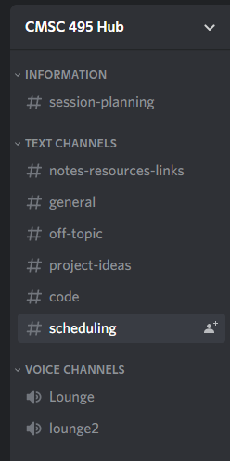

*Figure 1*. Discord Setup

The first meeting was a means to get to know each other and learn everyone’s strengths and weaknesses. Every single team member provided several ideas for an application programs, and we collectively decided on LivExpress web application. Once we decided on the type of application, the program language, and software requirements that would be needed to successfully design and develop the project, we were able to assign roles, accordingly, based off each team members respected skill set. We discussed early on that life happens and/or certain tasks maybe more challenging than expected for one team member; therefore, it was imperative to keep communicating as much as we can and do our best to adhere to our designated meeting day and time we established. George created a schedule for everyone with all assignments and their due dates; as well as the scheduled meetings we would have weekly. This allowed everyone to keep up with our milestones to stay on track with the project development. Catrina provided some basic HTML to help display a basic rough draft to get a sense of what our project truly entailed. Once we all got a better understanding of the project plan, Wanner worked on the first draft of the plan; in which he shared with the team during the meeting. The team was able to make edits to the document and provide feedback, edits, and changes during our team collaboration. The rest of the documentation for this project was conducted in the same manner. Each team member had a chance to start a rough draft for the team, and then during our meeting the document was shared with all team members who made contributions to the feedback, edits, and changes. The rough draft of the project was passed on to Franklin, who revised it to build the entire web frame, which really brought the web application to life. After each software design stage, Merga and George would test and analyze the code and provide necessary feedback and edits to the code which maintained the software was properly integrating and interacting with all functions and aspects of the project. Once the web frame was built, and we knew what each HTML page would consist of, Wanner hopped on the configuration of the entire SQL database that would allow user data to be securely stored, and where specific data could be maintained and retrieved. The database is exactly what made the wheels for the functionality of the program turn smoothly. While building the database to work with the code, Wanner modified the web frame, which was utilized during phase II. Merga and George were on top of the code and found some bugs in the program. They were on top of the fixes to ensure that the development of the project could commence without major issues arising. This was extremely helpful as it kept production moving smoothly. Catrina built the About Us page along with the Contact Us form that would, upon form submission, send to [livexpress.help@gmail.com](mailto:livexpress.help@gmail.com) account created. The group utilized team pairing to edit, update, and modify the front-end web pages, in which users would use to interact with in the web application. Even though individual roles were assigned, we realized that we were strong if we paired with one another to build the web application to the best of our ability. An application that would appeal to the users, and one we were proud of. Each team member pulled their weight and did produced a product we are all proud of. Being able to lean on each other and piggyback from each other made the team stronger and work in unison to complete a functioning web application.

## Communication

Discord is the program that each team member will utilize in order to communicate with each other. We will hold weekly meetings in the lounge inside Discord every Sunday at 12 pm EST. Anytime someone has a questioner needs help with part of the project, they can send an instant message on Discord where other team members can chime in. This has been downloaded on our computers and our phones so that we stay in communication with one another 24/7.

Smart sheets is another software program that all team members have been granted access to. Smart sheets house the live documents that the team can view regarding the aspects of the team project; as well as a document that team members will need to document all project tasks each time someone works on a part of the project. That Way, the team can keep up with all track changes that have been made and/or are being currently worked on. It also keeps everyone on the same page with what everyone is doing and tasks that have been completed or still needing some attention. We will also attach all documentation associated with the project within Smart-sheets so that all team members have access to all of the documents.

# PROJECT PLAN

## Project Objectives

* Develop a software development life cycle (SDLC) using the waterfall method.
* Create website design and build website diagram.
* Write the project plan.
* Implementation.
* Create an open-sourced website platform that allows users to post and share places they have explored in a live feed.
* Website will allow users to search for keywords that will populate anything with the keyword in it.
* Website provides a place for users a way to search and find new things to try.
* Website allows users who are traveling to locate suggested spots to visit during their travels.

## Project Scope

LivExpress is a website platform that will allow users from diverse geographical locations to post and share places they have explored. The posts will be shared in a live feed that will show all places users have visited and posted. The platform is not limited to geographical points since the users can review and post eateries, activities, and fun centers they have visited. The flask framework, pyrebase, and virtualenv libraries will be installed using pip3 and used to develop the platform. The LivExpress platform will allow users to register and create a login to the website for free. Once a user is registered and logs in, they will be able to share their explorations, which will offer unique experiences to all the subscribers.

We are starting to see light at the end of the tunnel after being couped up in the house due to the world being shut down due to Covid-19. It is time that people get back to living and seeing the world again, and the wonders it has to offer. This platform is designed for any individual who is looking to find those hidden treasures of the world.

LivExpress adopts the agile methodology; in which, will be applied in order to develop the project. It is a development methodology that allows progress to flow steadily towards the final stage. It entails numerous phases, which include requirements, design, implementation, testing, deployment, and then maintenance. Each phase is essential as it builds a foundation for the next. The project needs to be completed within 7 weeks. No later than July 13, 2021.

# REQUIREMENTS SPECIFICATION

## Who Will Use the Website?

Anybody, anywhere in any geographical location.

## What Is It Used for?

This site is used for users who are exploring the world and have experienced something amazing that they want to share with other users of LivExpress. They can share live updates regarding amazing eateries, activities, and fun centers they have visited; as well as photos that they would like to attach. Users can also save posts with a hashtag, allowing other users or themselves to find what has been posted regarding that hashtag.

## How Will It Work?

As a non-user, you do not have to register and login and still have the option to post to the live feed. However, you do not have the option to update or delete the posts that you have previously shared. With a registered user, you can create posts to the live feed and have the option to update and delete any post that you have previously shared. Both users are also able to search for other user’s posts with either the hashtag, or the title of a post. There is a contact page that allows all registered and non-registered users to contact LivExpress with any questions that they have.

# SYSTEM SPECIFICATIONS

## Software

The program has been tested on Windows and MacOS devices. The program is built using Python version 3.6 and up.

## Hardware

When the program is deployed to the public, it will be available on all desktop models, but has not been made available for the mobile version.

# DESIGN AND ALTERNATE DESIGNS

## What Is a Software Design?

The process by which developers create a specification of a software artifact, intended to accomplish goals, using a set of primitive components and subject to constraints. Software design may refer to either "all the activities involved in conceptualizing, framing, implementing, commissioning, and ultimately modifying complex systems" or "the activity following requirements specification and before programming. It includes both low-level component and algorithm design and high-level architecture design.

## What Is a Software Design Alternative?

It is a two-software design with similar facilities of the same user interface (GUI), the same size, and with the same ultimate purpose. One could treat these two design alternatives as clone sites, with a significant amount of similar data, in the analysis.

The program has a detailed design and alternatives design that serves as a backup of the entire website's data. It also ensures that user data are fully protected on the alternatives software backups, including categories, user information, pages, blog posts, and more.

## Front-End

* The webpage is more interactive for the user.
* More dynamic for the user to understand, and it hides all the code on the back-end
* The user interface is user friendly, and it eliminates all the work that is being done on the back-end

## Back-End

* Collects data from the users input on the front-end.
* Manages the confidentiality of the users’ personal data.
* Manages the access of each user by the registration form.
* Stores the data from the users input into an SQL database to send, store, and retrieve this data for the user on the front-end.
* Helps the front-end manage the logic behind the users GET requests.

## GUI Design (First Draft & Mock-Ups)

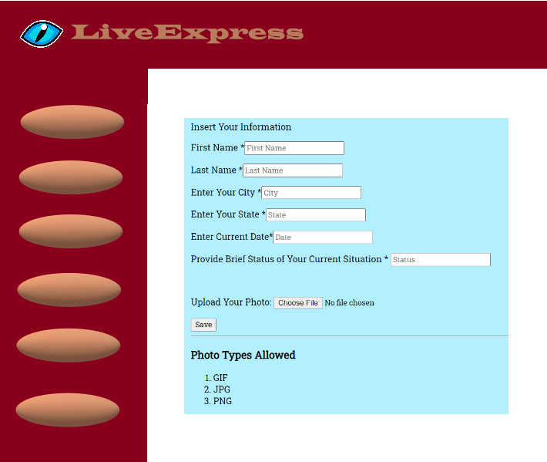

*Figure 2*. Mock-Up 1

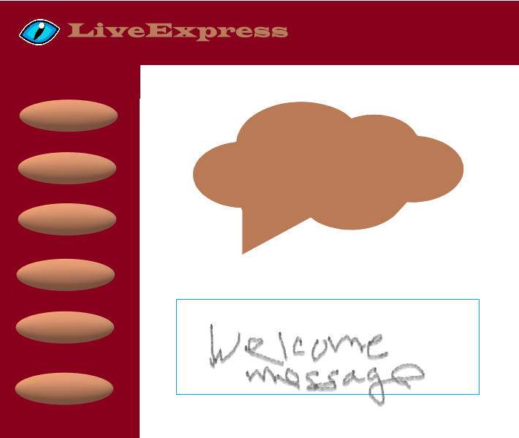

*Figure 3*. Mock-Up 2

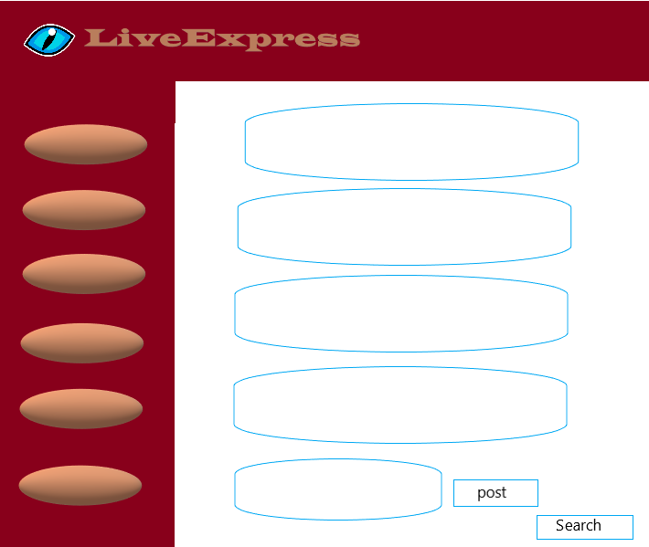

*Figure 4*. Mock-Up 3

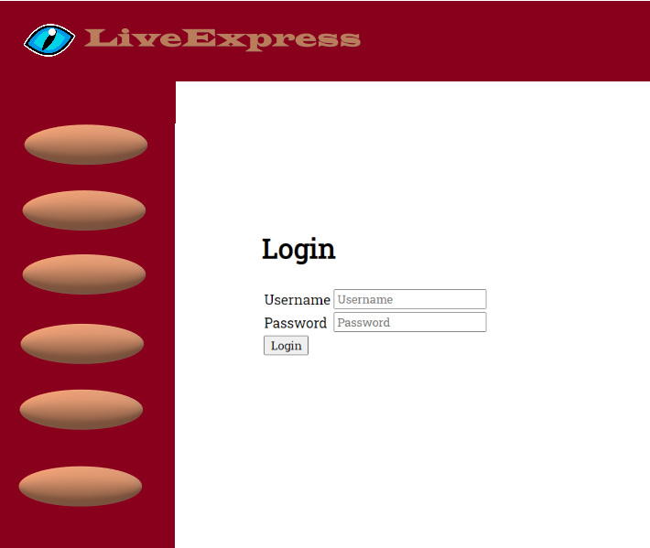

*Figure 5*. Mock-Up 4

## Wireframes

### Home Page Wireframe

Below, in Figure 6, is the project design homepage. It will have a nav bar that contains links to all the pages within the website.

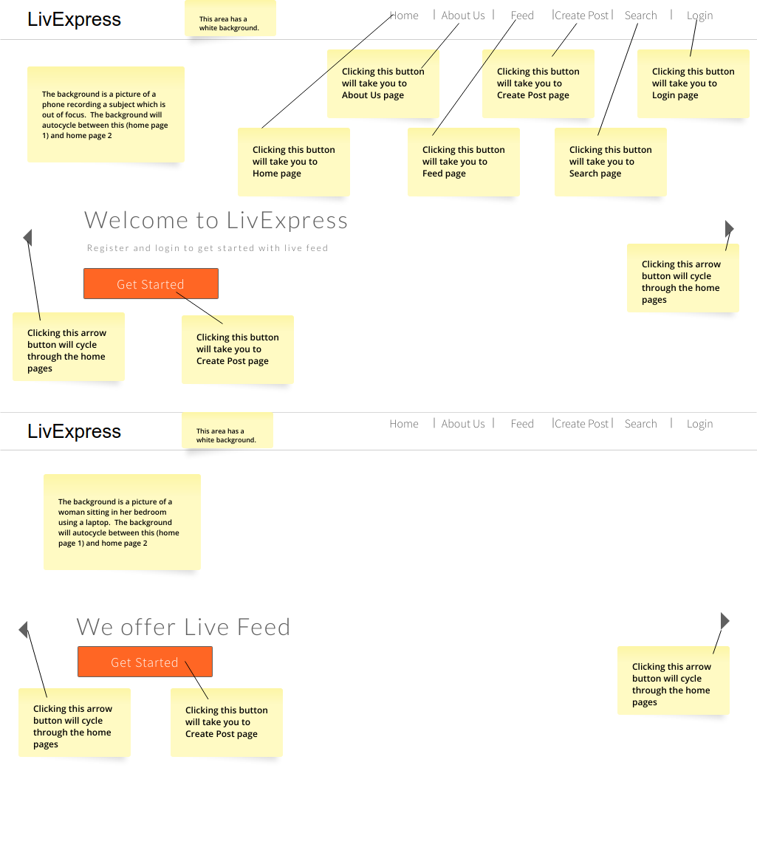

*Figure 6.* Home Page Wireframe

* **User Function:**
* Guest clicks the *Get Started* page to begin posting to the feed.
* If user wants to register or login, they can click the *Register* or *Login* buttons that allow them to enter the site as a registered user, and in return, the user is given a username.
* This page will be designed using HTML, CSS, and Bootstrap.
* **Limitations/Potential Errors:**
* There are no user entries for this wireframe

### Register Page Wireframe

This project design shown in Figure 7*,* contains the registration form, in which the user will input data into the fields that will be stored into the database. These fields will be used to grant access to the user upon login.

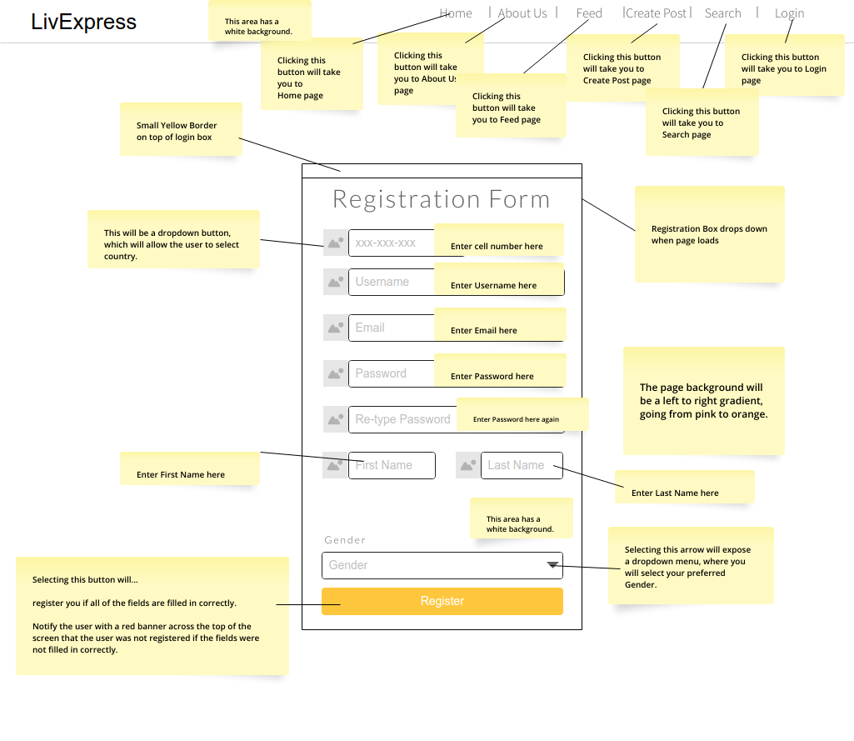

*Figure 7.* Register Page Wireframe

* **User Function:**
* User enters ALL required fields.
* User clicks the *Register* button to submit their registration form.
* This page will be designed using a form which has JavaScript’s, HTML, CSS, and Bootstrap.
* **Limitations/Potential Errors:**
* Fields that are required… (phone number, username, email, password, re-type password, first name, last name, gender). If user does not input into these required fields, an error message tells the user that they*\*must enter all required fields.*

### Login Page Wireframe

The screenshot in Figure 8*,* below, depicts the login screen. The user inputs the login information into the fields, in return, is retrieved from the database. If the input data is valid, the user will be granted access to the LivExpress site.

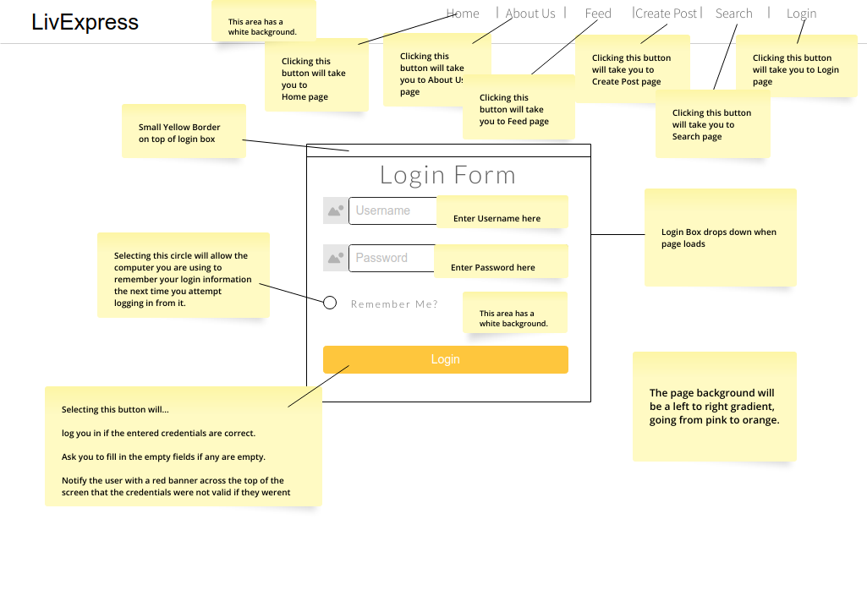

*Figure 8.* Login Page Wireframe

* **User Function:**
* User must enter login and password fields.
* User clicks the *Login* button to login to the website.
* This page will be designed using a form which has JavaScript’s, HTML, CSS, and Bootstrap.
* **Limitation/Potential Errors**
* Fields that are required… (username and password). If user does not input into these required fields, an error message will pop-up, telling the user to *\*please fill out this field*.
* If username or password is incorrect, then an error message pops-up stating *\*login unsuccessful, please try again*.

### Create Post Page Wireframe

The page below, in Figure 9*,* allows a user to create a post that they would like uploaded into the live feed page, which is linked to the create post page. The user will enter keywords (known as hashtags), along with a title, content, and a button to upload a photo from their desktop.

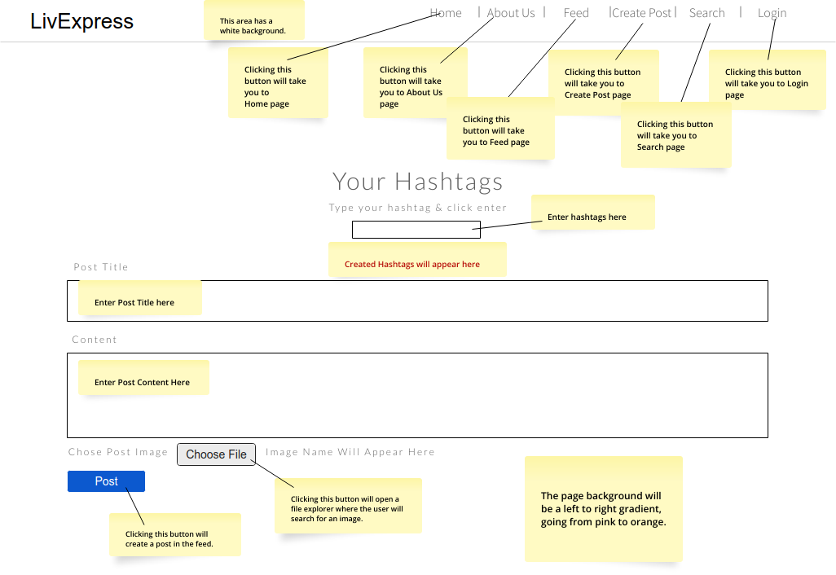

*Figure 9.* Create Post Wireframe

* **User Function:**
* User/Guest enters data input into the fields.
* Hashtags are entered into the hashtag field.
* User can upload photo that is stored on their computer.
* This page will be designed using a form which has JavaScript’s, HTML, CSS, and Bootstrap.
* **Limitations/Potential Errors:**
* User can enter hashtag words; however, if the user does not press *enter,* then the word will not be saved.
* The post content is limited to 250 words, if the user goes over 250 characters, they will see an error message stating, *\*Cannot proceed 250 characters.*

### Feed Page Wireframe

In the wireframe below, in Figure 10*,* ALL user posts are shown in chronological order. The update and delete buttons are only visible depending on the user’s level of access. To view the posts, users scroll up and down on the screen.

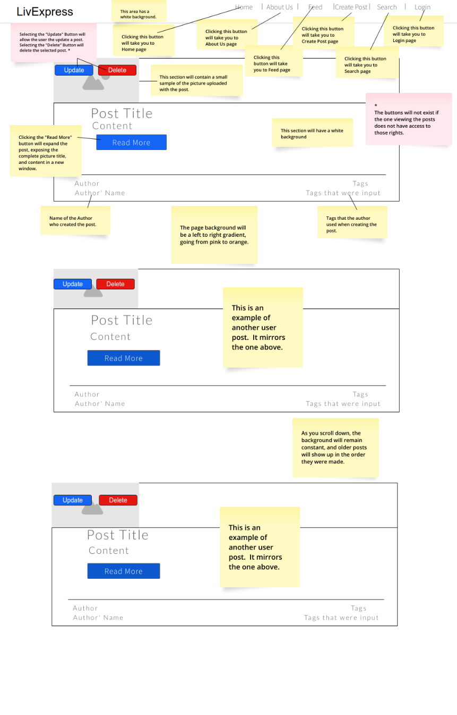

*Figure 10.* Feed Page Wireframe

* **User Function:**
* User/Guest can scroll up and down on the page to see the feed in chronological order.
* User/Guest can click on the *Read More* button to redirect to a single posts image and content.
* User can update or delete a post that they have created.
* Admins can update and delete posts that the end-users have created.
* This page will be designed using a form which has JavaScript’s, HTML, CSS, Bootstrap, and SQLite.
* **Limitations/Potential Errors:**
* If utilizing the feed as a guest, they are limited to *only* scrolling up and down on the feed. They do not have the option to update or delete posts that they have created.
* If utilizing the feed as a registered user, they can update and delete posts that they have created. They are limited to updating and deleting *only* their posts and no one else’s.

### Search Post Page Wireframe

The search page uses a database scan or query to filter the search inputted by the user, which is shown in the Figure 11*,* below. The user can search by either the title or the hashtags of a post. If no matches to the search are found, then no feeds will be displayed.

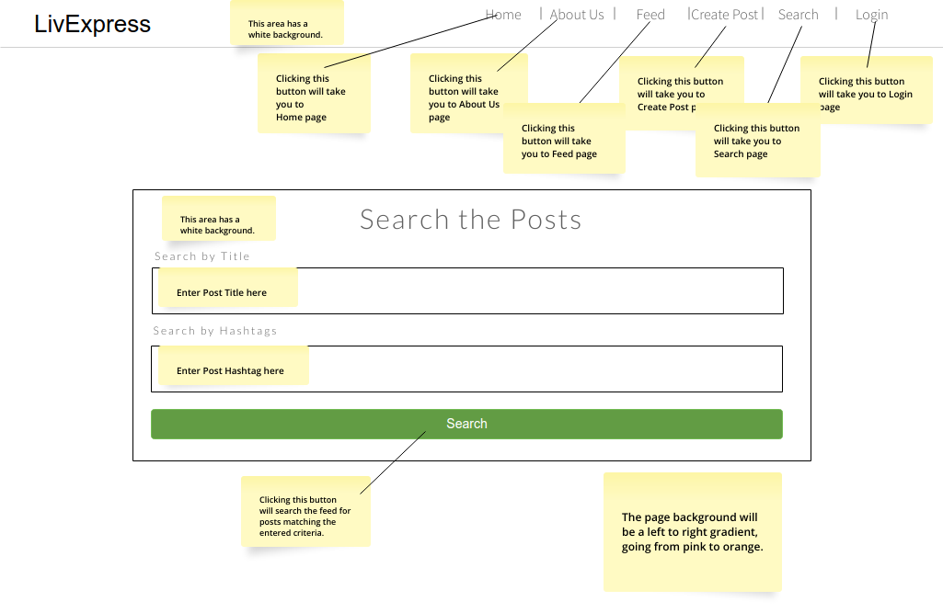

*Figure 11.* Search Post Page Wireframe

* **User Function:**
* User/Guest enters data input into the *Search by Title* fields.
* User/Guest enters data input into the *Search by Hashtags* fields.
* *Search* button runs search and will display the results on the feed page.
* This page will be designed using a form which has HTML, CSS, and SQLite.
* **Limitations/Potential Errors:**
* There are unlimited searches for the keywords within title and hashtag.
* There is a 180-character limit on ALL searches.

### About Us Page Wireframe

The page gives the user a brief description of what LivExpress is all about. It shows the photos of the team members who created the site and provides a contact button that will render a contact form page. See Figure 12*,* below.

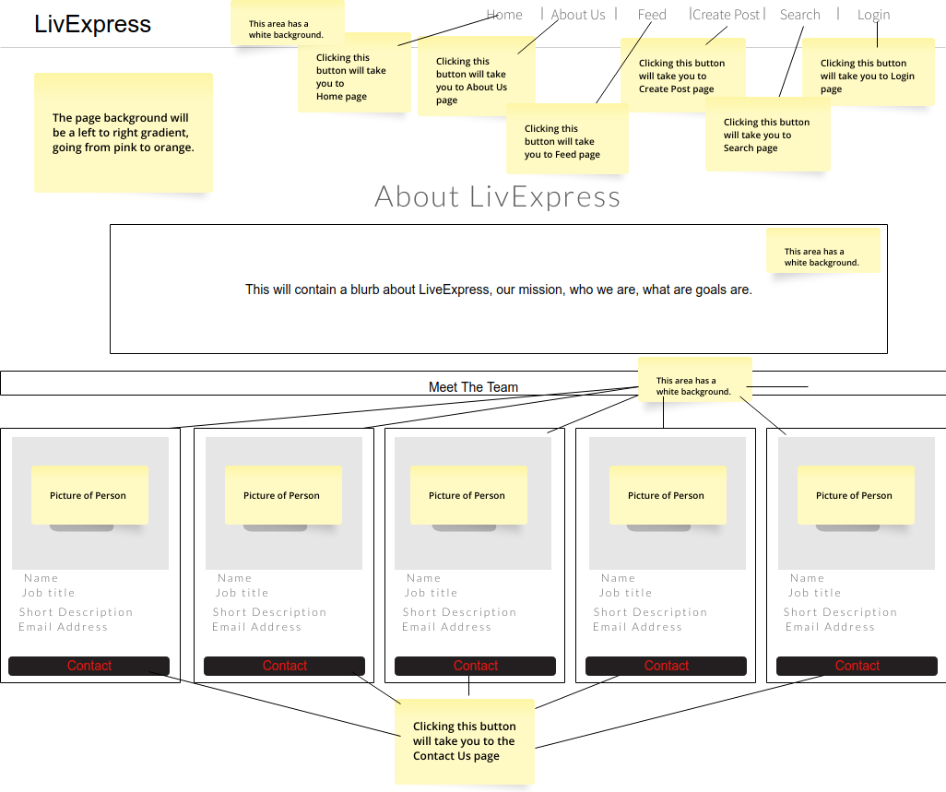

*Figure 12.* About Us Page Wireframe

* **User Function:**
* The only button on this page is the *Contact* button that will redirect the user to a contact page form.
* This page will be designed using a form which has HTML and CSS.
* **Limitations/Potential Errors**
* There are no user entries or limitations for this wireframe.

### Contact Us Page Wireframe

A form is provided to the user that allows them to enter data into the fields with a reason and brief message that will be sent to the team, as shown in Figure 13*,* below.

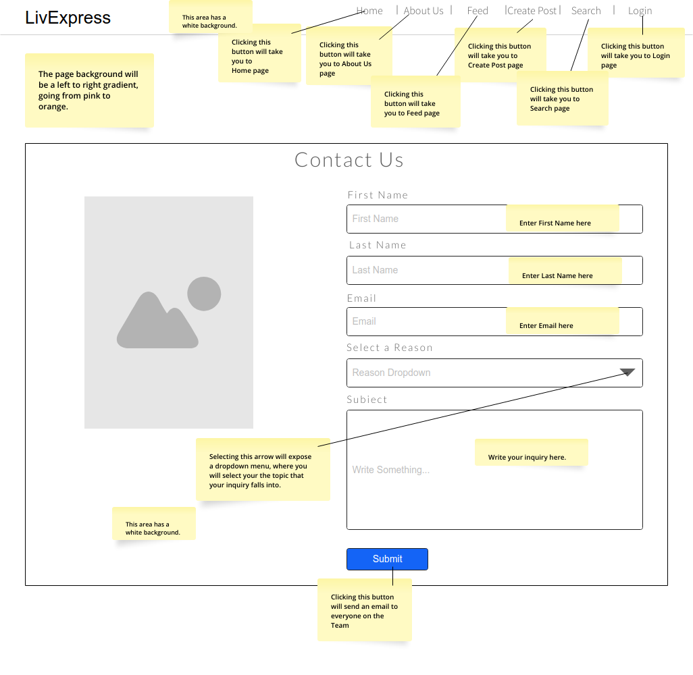

*Figure 13.* Contact Us Page Wireframe

* **User Function:**
* Data input fields are ALL required.
* *Submit* button sends all input fields in the form to the registered [livexpress.help@gmail.com](mailto:livexpress.help@gmail.com) account.
* This page will be designed using a form which has HTML and CSS.
* **Limitations/Potential Errors:**
* All fields are required… (first name, last name, email, selected reason, subject).
* If user did not input data into the required field, an error message pops up stating, *\*All fields are required before submitting.*

## Site Map (Flow Diagram)

As described in the highlighted portion of the project objectives, the use case diagram shown in *Figure 14,* has been generated to better visualize how the program will work for the end-users.

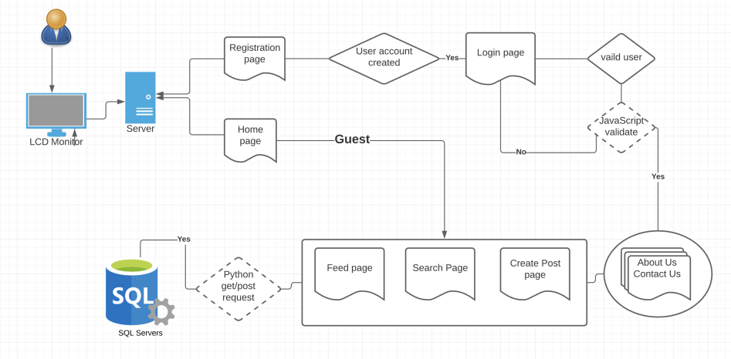

*Figure 14.* Flow Diagram

# USER GUIDE

## User Guide Overview

The user guide will provide detailed directives that will assist the user on how to properly navigate through the LivExpress website with ease. It provides detailed directives for each link displayed in the Navbar, and how it will help a user understand the purpose of each web page. The guide also provides detailed instructions on how to properly install and make the software ready to be utilized.

## Installation Requirements

### Prerequisites

* Have Google Chrome, Safari, or Edge Installed on Desktop
* Have project open in IDE of choice (We used PyCharm)
* Open the read-me file and install all the needed package requirements shown in Figure 58, below.

### Instructions On How to Run and Test the Project

1. Open the zip folder and unzip the file to your desktop.
2. Run the program with flask in your IDE:
   1. Go to the terminal and type *set flask_env=development* and press ENTER.
   2. Type *flask run* and press ENTER.
   3. Then the program will open in your browser.
3. Your browser will render the Home page.

### Common Installation Troubleshooting

* I have installed all the requirements, but the program will not run.
  + Go to File > Close Projects.
  + Close your IDE.
  + Re-open the IDE and re-open the project.
  + Attempt to run it again.
* I ran the needed package requirements, but still am showing some are missing.
  + A couple of these packages may not install due to issues with the IDE, do not worry about these.

You are now ready to test!

## Navbar Menu

The Navbar (Figure 15) is located at the top of the website on every page. It houses the links that allow the user to navigate between all areas of the website, as necessary.



Figure 15. Nav bar

* Home
* About Us
* Feed
* Create Post
* Search
* Login
* Register (Only displays if user is not logged in)
* Sign Out (Only displays if user is logged in)

A detailed description is provided for each link mentioned above, along with instructions to guide the user through the process, if needed.

## Home Page

Seen in the screenshot below (Figure 16*),* is the home page for LivExpress. This page is the very first page that will appear when a user visits the website.

1. User can click on Get Started and post as a guest.
2. Users can register as a new user or login to their existing account.

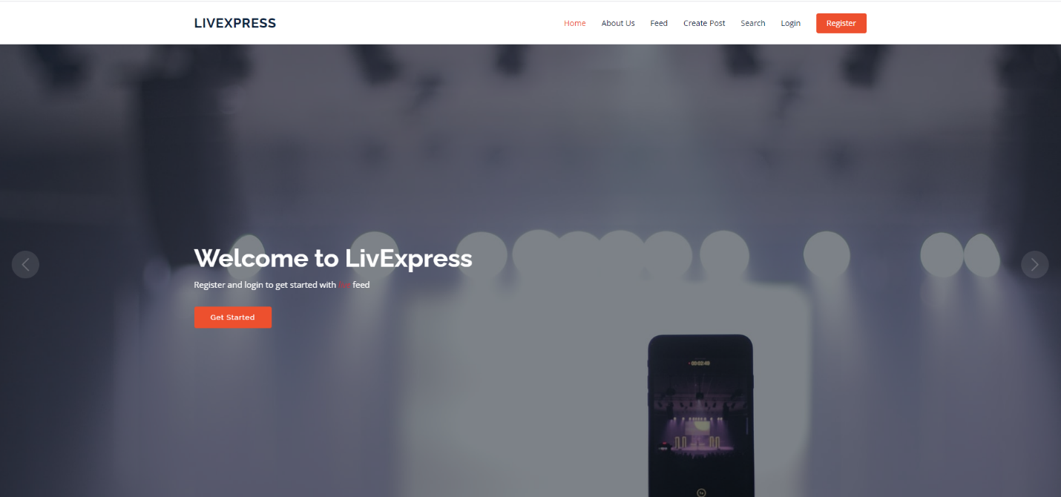

*Figure 16.* Home Page

## About Us/Contact Us Form

The sole purpose of the About Us page is to allow the users to learn who and what LivExpress is all about; as well as the individual web developers who created the site. The page also provides a contact form which gives the user an option to reach out to the LivExpress support team for any questions, comments, and or concerns they may have. A screenshot of the page can be seen below in Figures 17-19.

.

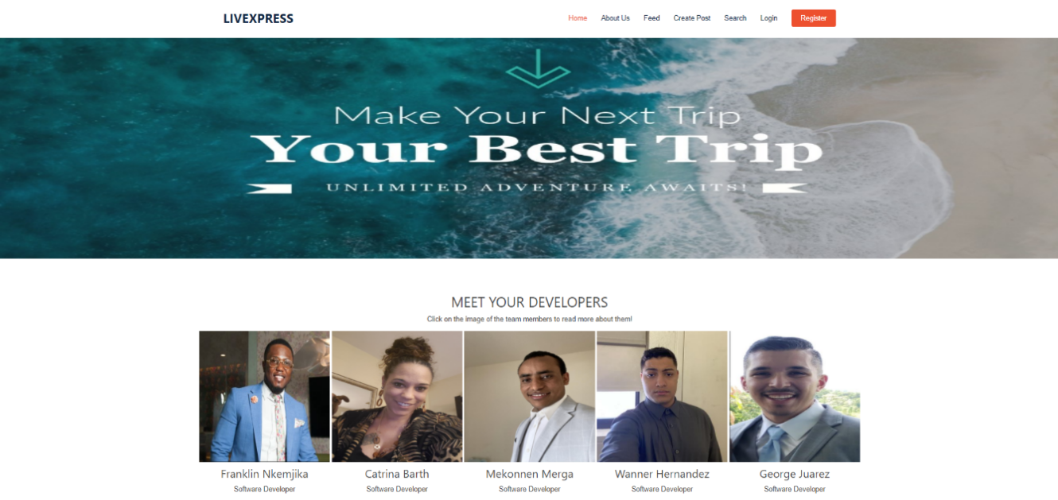

*Figure 17.* About Us Page

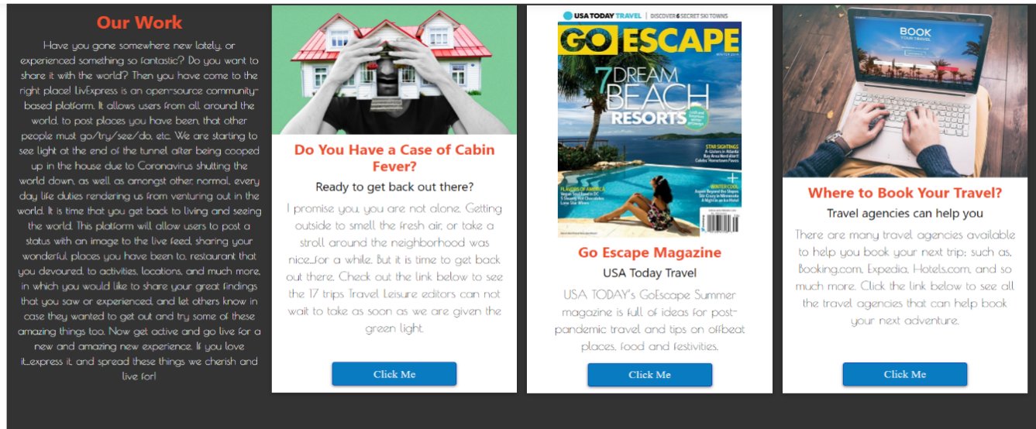

*Figure 18.* About Us Page Part 2

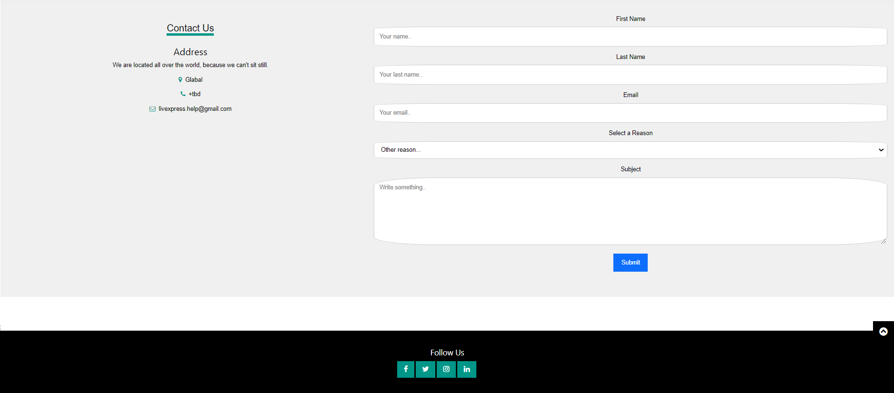

*Figure 19.* Contact Us Form

About Us:

1. User can view the about us page to learn more about LivExpress and their mission.
2. User can click the individual developer teams profile pictures to view their LinkedIn profile and learn more about each team member.

Contact Us Form:

1. A form that allows the user to contact LivExpress support team for any reason needed.
2. Select a reason to contact help using the dropdown menu option.
3. Hit “submit” button.

## Feed Page

The feed view offers real-time posts (seen in figure 16 below), from users who have explored exciting new places and adventures around the world and want to share with others who may be looking to experience something new as well.

The feed view offers real-time posts (seen in figures 20 & 21 below), from users who have explored exciting new places and adventures around the world and want to share with others who may be looking to experience something new as well.

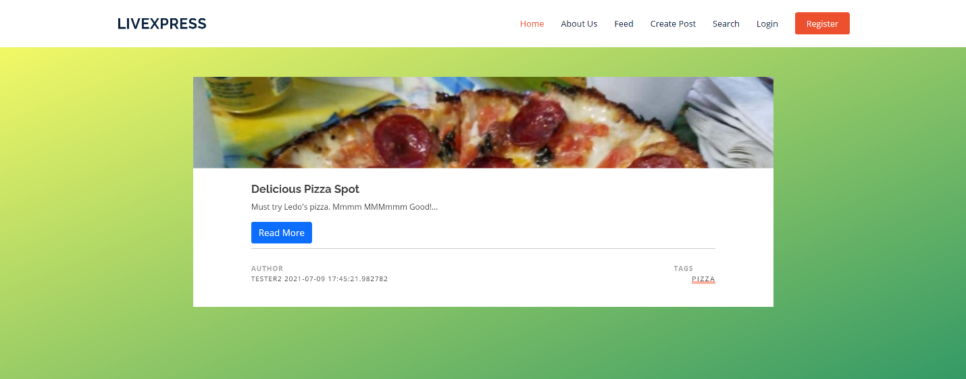

*Figure 20.* Feed Page

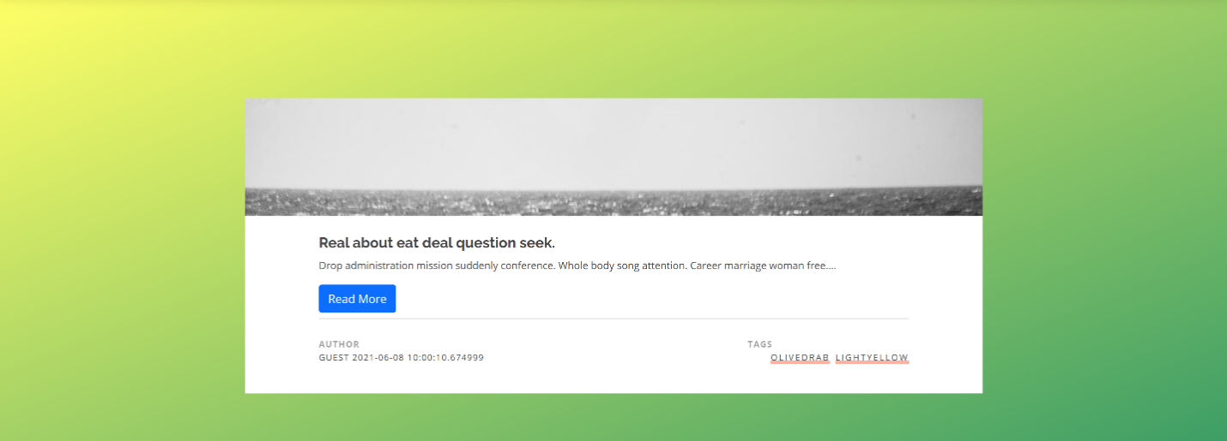

*Figure 21.* Feed Page Part 2

1. User can view all posts submitted to the feed in chronological order by scrolling down on the page.
2. ONLY if a user has registered and is successfully logged in, they can delete or update posts they have submitted using the buttons seen in F*igure 22* below, which are displayed at the top of their posts.

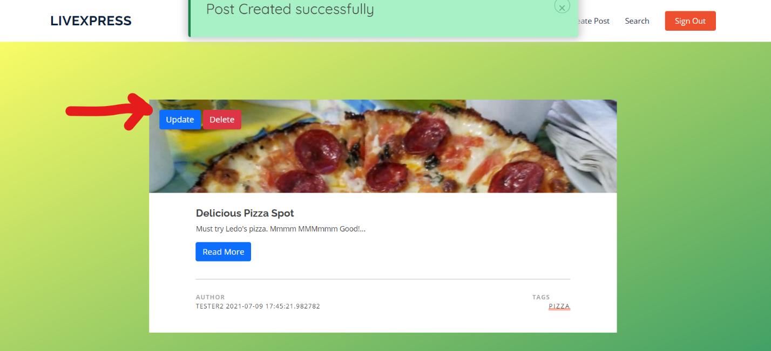

*Figure 22.* Update/Delete Post Options

### Create Post Page

For a user to share their new and exciting adventure, they must click the link to Create Post, seen in Figure 23 below. The user can attach multiple hashtags (keywords) that will assist another user searching for the hashtags to easily locate the things they are most interested in.

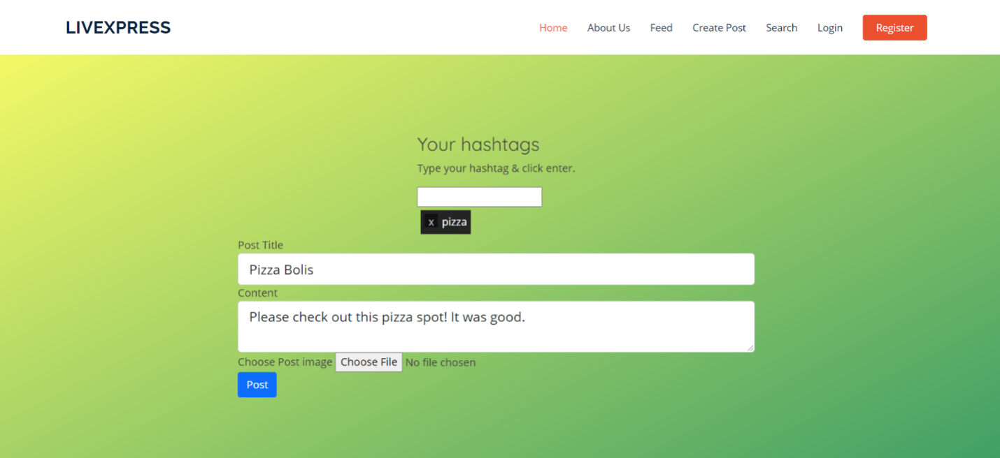

*Figure 23.* Create Post Page

1. User can enter hash-tag words, then press “Enter”.
2. All fields along with the image file are required before a user is able to submit the post. (ONLY image files are allowed).

## Search Page

All users have the capability to search for posts that have been submitted to the feed via hashtag (keywords), and/or a specific post’s title. You can see how this is done in Figure *24* below.

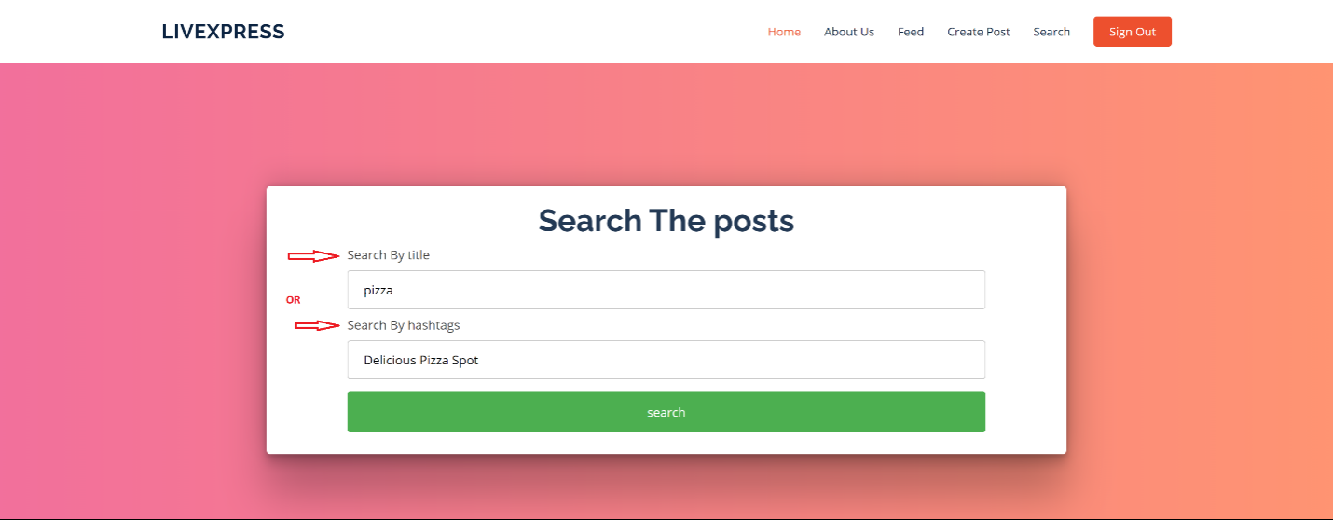

*Figure 24.* Search Page

* Registered and guests can search by the *hashtag* or *title* for posts that have been created by other users or themselves.

**Instructions**:

1. Navigate to the Search page (if not already there).
2. User can search for the hashtag or the title of a post.
3. Select “Search”.

## Login Page

If the user has already registered to gain access to the system, they can login via the login form (seen in figure 25 below), with their unique username and password. This allows their username to be attached to the posts they have added to the feed.

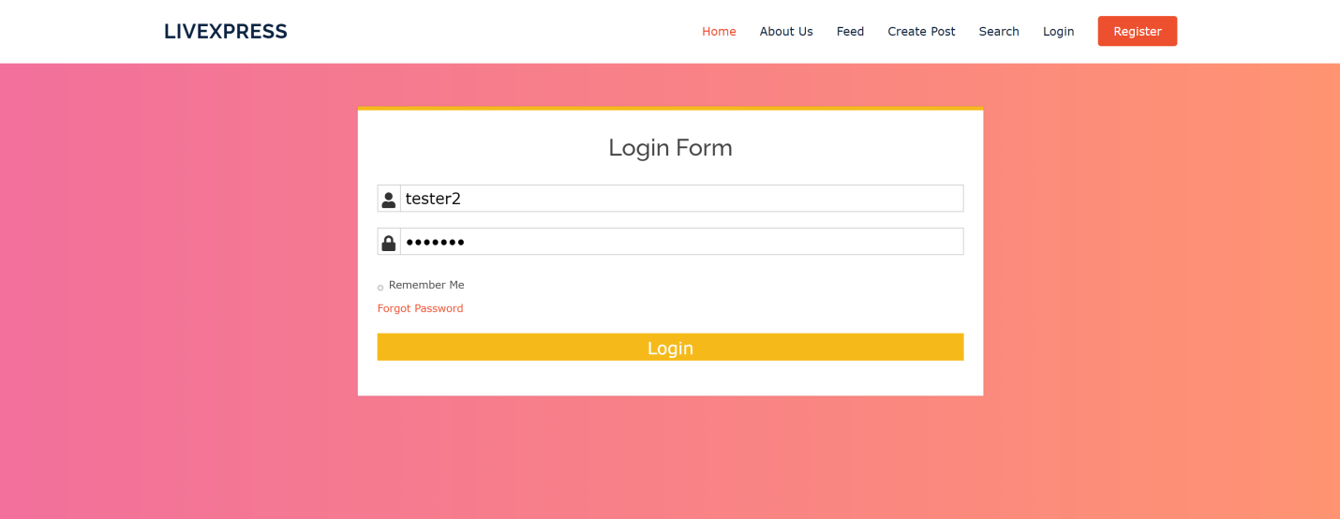

*Figure 25.* Login Page

* Authentication page that verifies a valid user.
* User must provide the correct username and password.

**Instructions**:

1. Navigate to the Login Page (if not already there).
2. Type in your username.
3. Type in your password.
4. Select “Login”.
   1. If user inputs incorrect username and/or password, an error message will pop-up stating, “Login Unsuccessful”. (See *figure 26).*

Also seen in Figure 26*,* is a ‘forgot username or password’ link, that will bring the user to the Contact Us form, found on the About Us page, seen in Figure 27*.*

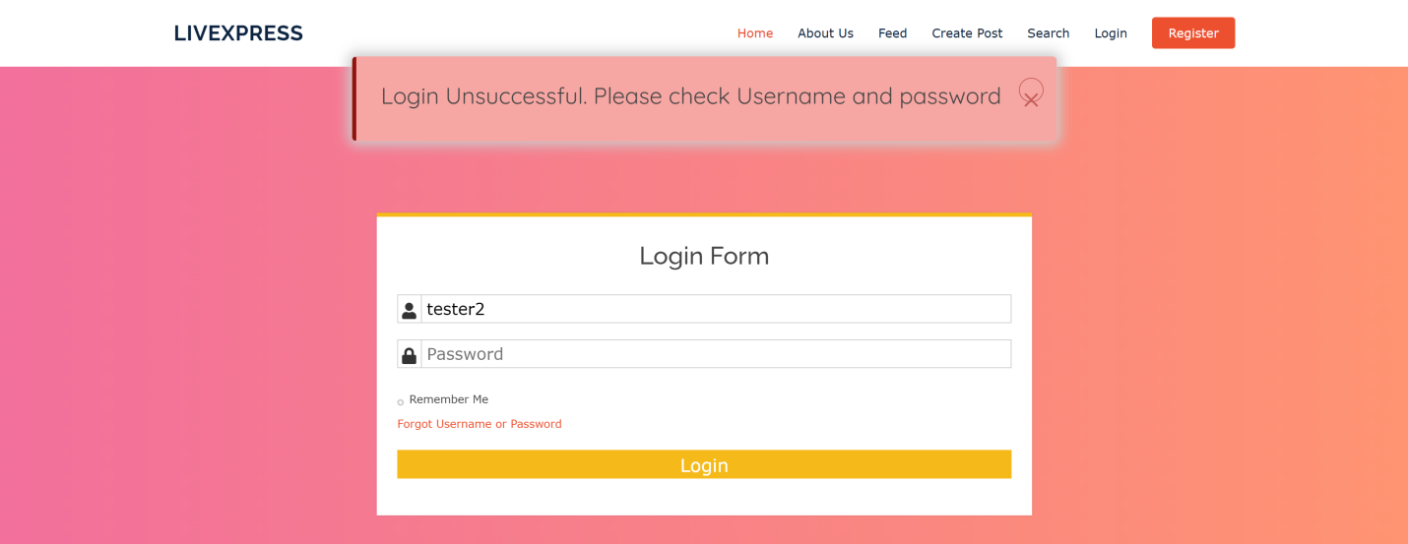

*Figure 26.* Unsuccessful Login

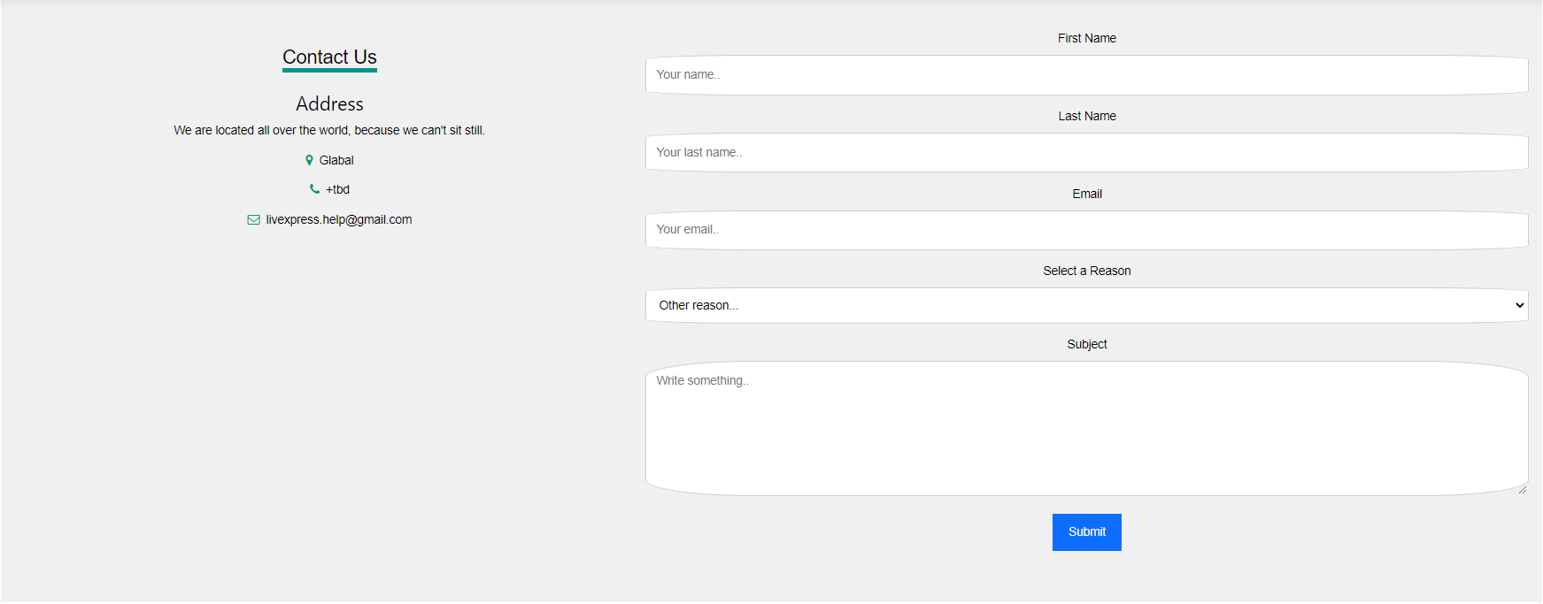

*Figure 27.* Directed to Contact UsPage

## Registration Page

For a user to have access to updating and deleting their own posts they have submitted to the feed; they must register to create their user account. The user will register for an account via the registration form seen in Figure 28 below.



*Figure 28.* Registration Page

* A form page that allows user to create an account.
* All fields are required upon registration.

**Instructions**:

1. Navigate to the Registration Page (if not already there).
2. Type in your information.
3. Select “Register”.

## Sign Out

Click the *Sign Out* button to logout of your user account (ONLY If logged in as a user)



*Figure 29.* Sign Out

If logged in, the user can hit the “logout” button to logout of their account.

# TEST PLAN

|  |  |  |  |
| --- | --- | --- | --- |
| Input Value/Action | Expected Output | Actual Output | Pass/Fail |
| Navbar: |  |  |  |
| Test 1:  Select “LivExpress” | The Home page is rendered | The Home page is rendered | Pass |
| Test 2:  Select “Home” | The Home page is rendered | The Home page is rendered | Pass |
| Test 3:  Select “Feed” | The Feed page is rendered | The Feed page is rendered | Pass |
| Test 4:  Select “Create Post” | The Create Post page is rendered | The Create Post page is rendered | Pass |
| Test 5:  Select “Search” | The Search page is rendered | The Search page is rendered | Pass |
| Test 6:  Select “Login” | The Login page is rendered | The Login page is rendered | Pass |
| Test 7:  Select “Register” | The Register page is rendered | The Register page is rendered | Pass |
| Home Page: |  |  |  |
| Test 1:  Click “Get Started” Button | The Create Post page is rendered | The Create Post page is rendered | Pass |
| Test 2:  Back Button | User is brought back to the page they were at previously. | User is brought back to the page they were at previously. | Pass |
| Test 3:  Navbar | The Navbar functions as expected. The corresponding links render the appropriate pages. | The Navbar functions as expected. The corresponding links render the appropriate pages. | Pass |
| About Us Page: |  |  |  |
| Test 1:  Select “About Us” | The About Us page is rendered | The About Us page is rendered | Pass |
| Test 2:  Select Individual Profile Photos | Renders the LinkedIn profile of the team member that was clicked. | Renders the LinkedIn profile of the team member that was clicked. | Pass |
| Test 3:  Test the ‘Click Me’ buttons | Renders an external site that provides more detail about the respected ad. | Renders an external site that provides more detail about the respected ad. | Pass |
| Test 4:  Back Button | User is brought back to the page they were at previously. | User is brought back to the page they were at previously. | Pass |
| Test 5:  Navbar | The Navbar functions as expected. The corresponding links render the appropriate pages. | The Navbar functions as expected. The corresponding links render the appropriate pages. | Pass |
| Contact Us Form |  |  |  |
| Test 1:  Enter First Name in First Name Field | User can enter first name in first name field. | User can enter first name in first name field. | Pass |
| Test 2:  Enter Last Name in Last Name Field | User can enter last name in last name field. | User can enter last name in last name field. | Pass |
| Test 3:  Enter Email in Email Field | User can enter email in email field. | User can enter email in email field. | Pass |
| Test 4:  Select Reason in Select a Reason Dropdown Menu | User can select a reason from the reason dropdown menu. | User can select a reason from the reason dropdown menu. | Pass |
| Test 5:  Enter Subject in Subject Field | User can enter subject in subject field. | User can enter subject in subject field. | Pass |
| Test 6:  Select “Submit” Button | The form is submitted to the LivExpress Team if all information is correct. If not, an appropriate message is displayed. | The form is submitted to the LivExpress Team if all information is correct. If not, an appropriate message is displayed. | Pass |
| Test 6a:  Leave First Name Blank | The form displays a message asking the user to input the required information. | The form displays a message asking the user to input the required information. | Pass |
| Test 6b:  Leave Last Name Blank | The form displays a message asking the user to input the required information. | The form displays a message asking the user to input the required information. | Pass |
| Test 6c:  Leave Email Blank | The form displays a message asking the user to input the required information. | The form displays a message asking the user to input the required information. | Pass |
| Test 6d:  Leave Reason Blank | An Error 500 message that specifies the format problem is rendered. | An Error 500 message that specifies the format problem is rendered. | Pass |
| Test 6e:  Leave Subject Blank | An Error 500 message that specifies the problem is rendered. | An Error 500 message that specifies the problem is rendered. | Pass |
| Feed Page: |  |  |  |
| Test 1:  Click “Read More” Button | The post is opened in a new page. The picture title, and context are viewable. | The post is opened in a new page. The picture title, and context are viewable. | Pass |
| Test 2:  Back Button | User is brought back to the page they were at previously. | User is brought back to the page they were at previously | Pass |
| Test 3:  Admin Update | Admin has option and is able to update any post on the feed. | Admin has option and is able to update any post on the feed. | Pass |
| Test 4:  Admin Delete | Admin has option and is able to delete any post on the feed. | Admin has option and is able to delete any post on the feed. | Pass |
| Test 5:  User Update Own Post | User has option and is able to update own post on the feed. | User has option and is able to update own post on the feed. | Pass |
| Test 6:  User Delete Own Post | User has option and is able to delete own post on the feed. | User has option and is able to update own post on the feed. | Pass |
| Test 7:  User Update Other’s Post | User does not have option and is not able to update others post on the feed. | User does not have option and is not able to update others post on the feed. | Pass |
| Test 8:  User Delete Other’s Post | User does not have option and is not able to delete others post on the feed. | User does not have option and is not able to delete others post on the feed. | Pass |
| Test 9:  Navbar | The Navbar functions as expected. The corresponding links render the appropriate pages. | The Navbar functions as expected. The corresponding links render the appropriate pages. | Pass |
| Create Post Page: |  |  |  |
| Test 1:  Enter Hashtags in Hashtag Field | User can enter hashtag in hashtag field. | User can enter hashtag in hashtag field. | Pass |
| Test 2:  Enter Post Title | User can enter title in title field. | User can enter title in title field. | Pass |
| Test 3:  Enter Content | User can enter content in content field | User can enter content in content field | Pass |
| Test 4:  Click “Choose File” Button | A file explorer is opened | A file explorer is opened | Pass |
| Test 5:  Chose an accepted file type | File name appears next to “Choose File” button. | File name appears next to “Choose File” button. | Pass |
| Test 6:  Click “Post” Button | The post is created and posted to the feed with the input content if all information is correct. If not, an appropriate message is displayed. | The post is created and posted to the feed with the input content if all information is correct. If not, an appropriate message is displayed. | Pass |
| Test 6a:  Leave Hashtag Blank | The form will accept no hashtag as an acceptable input. | The form will accept no hashtag as an acceptable input. | Pass |
| Test 6b:  Leave Post Title Blank | The form displays a message asking the user to input the required information. | The form displays a message asking the user to input the required information. | Pass |
| Test 6c:  Leave Content Blank | The form displays a message asking the user to input the required information. | The form displays a message asking the user to input the required information. | Pass |
| Test 6d:  Does Not Choose a File to Upload | No action is taken. | No action is taken. | Pass |
| Test 6e:  Chooses a File Other Than Accepted File Types | An Error 500 message that specifies the format problem is rendered. | An Error 500 message that specifies the format problem is rendered. | Pass |
| Test 7:  Back Button | User is brought back to the page they were at previously. | User is brought back to the page they were at previously. | Pass |
| Test 8:  Navbar | The Navbar functions as expected. The corresponding links render the appropriate pages. | The Navbar functions as expected. The corresponding links render the appropriate pages. | Pass |
| Search Page: |  |  |  |
| Test 1:  Enter Title in Title Field | User can enter title in title field. | User can enter title in title field. | Pass |
| Test 2:  Enter Hashtag in Hashtag Field | User can enter hashtag in hashtag field | User can enter hashtag in hashtag field | Pass |
| Test 3:  Select “Search” Button |  |  |  |
| Test 3a:  Title and Hashtag Were Entered in Appropriate Fields | The feed is searched by title and hashtag. | The feed is searched by title and hashtag. | Pass |
| Test 3b:  Only Title Was Entered | The feed is searched by title. | The feed is searched by title. | Pass |
| Test 3c:  Only Hashtag Was Entered | The feed is searched by hashtag. | The feed is searched by hashtag. | Pass |
| Test 3d:  Neither Title or Hashtag Were Entered | The standard feed page is rendered. | The standard feed page is rendered. | Pass |
| Test 4:  Back Button | User is brought back to the page they were at previously. | User is brought back to the page they were at previously. | Pass |
| Test 5:  Navbar | The Navbar functions as expected. The corresponding links render the appropriate pages. | The Navbar functions as expected. The corresponding links render the appropriate pages. | Pass |
| Login Page: |  |  |  |
| Test 1:  Enter Username in Username Field | User can enter username in username field. | User can enter username in username field. | Pass |
| Test 2:  Enter Password in Password Field | User can enter password in password field | User can enter password in password field | Pass |
| Test 3:  Click “Login” Button |  |  |  |
| Test 3a:  Login Information was Correct | User is logged in. | User is logged in. | Pass |
| Test 3b:  Login Information was Incorrect | User is not logged in and notified of unsuccessful logon. | User is not logged in and notified of unsuccessful logon. | Pass |
| Test 3c:  No Username was Entered | If any field is empty, the user is notified | If any field is empty, the user is notified | Pass |
| Test 3d:  No Password was Entered | If any field is empty, the user is notified | If any field is empty, the user is notified | Pass |
| Test 4:  Select “Forgot Username or Password” Link | User is re-directed to Contact Us form | User is re-directed to Contact Us form | Pass |
| Test 5:  Back Button | User is brought back to the page they were at previously. | User is brought back to the page they were at previously. | Pass |
| Test 6:  Navbar | The Navbar functions as expected. The corresponding links render the appropriate pages. | The Navbar functions as expected. The corresponding links render the appropriate pages. | Pass |
| Register Page: |  |  |  |
| Test 1:  Enter Phone Number in Phone Number Field | User can enter phone number in phone number field. User is also able to select country from drop down menu. | User can enter phone number in phone number field. User is also able to select country from drop down menu. | Pass |
| Test 2:  Enter Username in Username Field | User can enter username in username field. | User can enter username in username field. | Pass |
| Test 3:  Enter Email in Email Field | User can enter email in email field. | User can enter password in password field | Pass |
| Test 4:  Enter Password in Password Field | User can enter password in password field. | User can enter password in password field | Pass |
| Test 5:  Re-enter Password in Re-enter Password Field | User can enter password in password field. | User can enter password in password field | Pass |
| Test 6:  Enter First Name in First Name Field | User can enter first name in first name field. | User can enter password in password field | Pass |
| Test 7:  Enter Last Name in Last Name Field | User can enter last name in last name field. | User can enter password in password field | Pass |
| Test 8:  Select Gender in Gender Drop Down Menu | User can select between male and female in gender drop down menu. | User can select between male and female in gender drop down menu. | Pass |
| Test 9:  Click “Register” Button | If any field is empty, the user is notified. | If any field is empty, the user is notified. | Pass |
| Test 9a:  No Phone number | An Error 500 message that specifies the problem is rendered. | An Error 500 message that specifies the problem is rendered. | Pass |
| Test 9b:  No Username | The form displays a message asking the user to input the required information. | The form displays a message asking the user to input the required information. | Pass |
| Test 9c:  No Email | The form displays a message asking the user to input the required information. | The form displays a message asking the user to input the required information. | Pass |
| Test 9d:  No Password | The form displays a message asking the user to input the required information. | The form displays a message asking the user to input the required information. | Pass |
| Test 9e:  No Re-Enter Password | The form displays a message asking the user to input the required information. | The form displays a message asking the user to input the required information. | Pass |
| Test 9f:  No First Name | The form displays a message asking the user to input the required information. | The form displays a message asking the user to input the required information. | Pass |
| Test 9g:  No Last Name | The form displays a message asking the user to input the required information. | The form displays a message asking the user to input the required information. | Pass |
| Test 10:  Back Button | User is brought back to the page they were at previously. | User is brought back to the page they were at previously. | Pass |
| Test 11:  Navbar | The Navbar functions as expected. The corresponding links render the appropriate pages. | The Navbar functions as expected. The corresponding links render the appropriate pages. | Pass |
| Sign Out Button: |  |  |  |
| Test 1:  No Sign Out button | The button does not appear if user is using site as a Guest | The button does not appear if user is using site as a Guest | Pass |
| Test 2:  Sign Out button appears in navbar | The button appears if the user is signed into their account. | The button appears if the user is signed into their account. | Pass |

*Table 2*. Test Plan

# INPUT VALIDATION

Before getting into Input validation, valid input must first be defined.

## Appropriate File Types

* .jpg
* .gif
* .mpg

## Phone Number

* Must be 10 digits (7 digit number + area code)

## Username

* 2 – 30 characters
* Must be unique.

## Email

* Must contain an appropriate domain.
  + @gmail.com
  + @yahoo.com
  + @hotmail.com
  + Etc.

## Password

* Must be 1east least 12 characters long.
* Must contain at least 1 lowercase letter.
* Must contain at least 1 uppercase letter.
* Must contain at least 1 special character.
* No spaces.

## Input Validation Test Cases

|  |  |  |  |
| --- | --- | --- | --- |
| Input Value/Action | Expected Result | Actual Result | Pass/Fail |
| Create Post Page: |  |  |  |
| Test 1:  File Chosen | The file type chosen will either be accepted or denied based on whether or not it is an accepted format |  |  |
| Test 1a:  .jpg | Accepted | Accepted | Pass |
| Test 1b:  .gif | Accepted | Accepted | Pass |
| Test 1c:  .json | Denied | Denied | Pass |
| Test 1d:  .txt | Denied | Denied | Pass |
| Test 1e:  .mp3 | Denied | Denied | Pass |
| Test 1f:  .doc | Denied | Denied | Pass |
| Registration Page: |  |  |  |
| Test 1:  Phone Number | The phone number will either be accepted or denied based on its adherence to LivExpress policy |  |  |
| Test 1a:  10 Digits (Numbers Only) | Accepted | Accepted | Pass |
| Test 1b:  5 Digits (Numbers Only) | Denied | Denied | Pass |
| Test 1c:  14 Digits (Numbers Only) | Denied | Denied | Pass |
| Test 1d:  Letters Only | Denied | Denied | Pass |
| Test 1e:  Letter and Numbers | Denied | Denied | Pass |
| Test 2:  Username | The username will either be accepted or denied based on its adherence to LivExpress policy |  |  |
| Test 2a:  12 Characters (Alphanumeric) | Accepted | Accepted | Pass |
| Test 2b:  14 Characters (Letters Only) | Accepted | Accepted | Pass |
| Test 2c:  13 Characters (Numbers Only) | Accepted | Accepted | Pass |
| Test 2d:  1 character (Letter Only) | Denied | Denied | Pass |
| Test 2e:  1 character (Number Only) | Denied | Denied | Pass |
| Test 2f:  1 character (Letters Only) | Denied | Denied | Pass |
| Test 2g:  32 Characters (Alphanumeric) | Denied | Denied | Pass |
| Test 2h:  31 Characters (Letters Only) | Denied | Denied | Pass |
| Test 2i:  35 Characters (Numbers Only) | Denied | Denied | Pass |
| Test 3:  Email | The email will either be accepted or denied based on its adherence to LivExpress policy |  |  |
| Test 3a:  @gmail | Accepted | Accepted | Pass |
| Test 3b:  @yahoo | Accepted | Accepted | Pass |
| Test 3c:  @fakeemail | Denied | Denied | Pass |
| Test 3d:  @notreal | Denied | Denied | Pass |
| Test 4:  Password | The Password will either be accepted or denied based on its adherence to LivExpress policy |  |  |
| Test 4a:  14 Characters (Uppercase, Lowercase, Number, Special Character) | Accepted | Accepted | Pass |
| Test 4b:  14 Characters (Lowercase, Number, Special Character) | Denied | Denied | Pass |
| Test 4c:  14 Characters (Uppercase, Number, Special Character) | Denied | Denied | Pass |
| Test 4d:  14 Characters (Uppercase, Lowercase, Special Character) | Denied | Denied | Pass |
| Test 4e:  14 Characters (Uppercase, Lowercase, Number) | Denied | Denied | Pass |
| Test 4f:  11 Characters (Uppercase, Lowercase, Number, Special Character) | Denied | Denied | Pass |

*Table 3*. Input Validation

# DEVELOPMENT HISTORY

A group of five software developers joined forces to create an application using the Agile methodology to successfully complete and deploy our project. The process, depicted in *Figure 30* below shows the agile approach the team took to create shorter development cycles that would produce swift deliveries of the software in just a few stages.

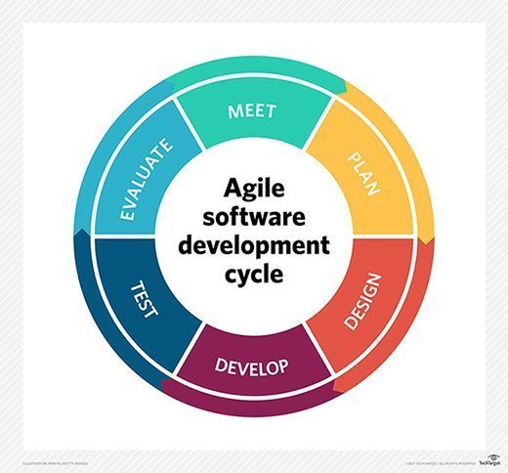

*Figure 30.* Unsuccessful Login *Agile Method retrieved from* [*Agile FAQ: Get started with these Agile basics (techtarget.com)*](https://searchsoftwarequality.techtarget.com/feature/Agile-basics-FAQ-Getting-started-with-Agile)*.*

We all put our heads together to brainstorm on ideas and came up with a web application called LivExpress. We drafted a project plan, along with specifications that would be referenced to aide in the design process. Mock-ups (seen on page 14) were drawn up to get a sense of how we wanted to design the web application. We then drafted a rough draft of the user guide to determine how all the pages would function. Once everything was documented in writing and with visuals, we began developing the first design phase of our project, which can be seen in *Figure 31* below.

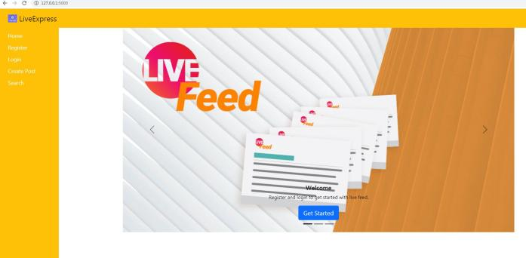

*Figure 31.* Initial LivExpress Design

We tested and evaluated the web application, which worked well for the first phase; however, after meeting again, we decided to revamp the site and make some more modifications. The team went back to the drawing board and created some wireframes that would depict the new modifications we agreed upon. See page 17 to view the wireframes that would now be built during the second phase of the development process. The new design shown below in F*igure 32,* was now ready to be tested and evaluated.

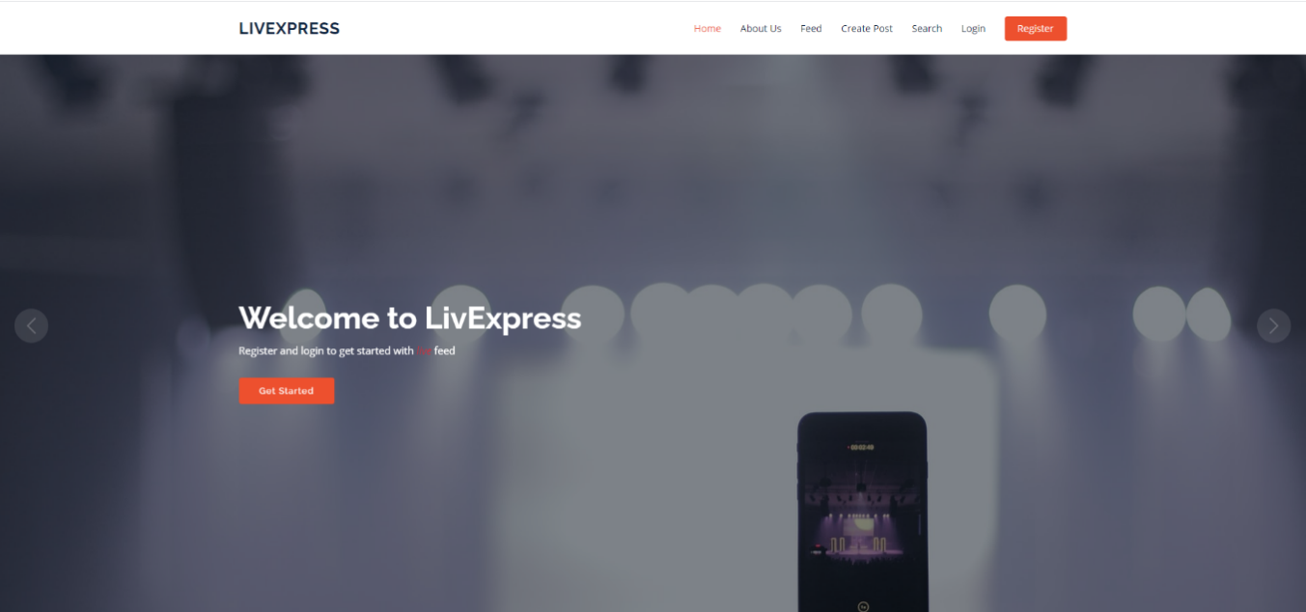

*Figure 32.* Second LivExpress Design

The team tested and evaluated the new design, which was a huge improvement from phase I design. During the final phase, a few adjustments and slight changes were modified to the design until everything worked and looked as intended. Once the team agreed on the final design and development of the web application, we went over the security of the software one last time before we felt assured that we could safely deploy the application. Securing the software is imperative to minimize the number of high-consequence targets; as well as, protecting every aspect of the data from getting attacked from someone with malicious intent. We made sure that developers, along with users were only able to access the areas of the software in which they were granted access too and restricted to the areas to ensure users data was protected. Tested the SQL database which houses pertinent user data to see if there were any areas that could be breached. We also tested any areas that had the potential to be vulnerable and with high-consequence components where attackers had the means to compromise. After all testing and evaluating was done, we looked over all the documentation and updated all changes that needed to be updated, and the team felt confident that LivExpress was ready to be deployed. You can view the re-cap of phase I, II, and III to see the process the team took to create the final product for LivExpress.

## Phase I

In phase I, we discussed the front-end portion of the website in which the users will interact with. The wireframes previously created and shown on pages 17 – 25, allowed the vision for the website, to be properly come to life in the design and development for the user interface (UI). All the pages that are used to navigate around the website from fonts, colors, background images, etc. were created with separate HTML pages that consisted of the Home page, About Us, Feed, Create Post, Search, Login, and Registration pages. All the pages were then incorporated together using the Python language on the back end (discussed in phase II Re-cap).

### Front-End/GUI Development

The front-end development came in three major stages, each of which was implemented on every page for the LivExpress Site.

1. Wireframe.
2. HTML writeup.
3. Viewing the site to ensure adherence to vision.

Steps 2 & 3 were repeated until satisfactory results were achieved for each page.

### Navbar

The Navbar is the tool that the user will utilize to easily navigate the LivExpress Site. The Navbar contains buttons that act as links to every page on the site and act to seamlessly connect the experience via a functional hub that stays consistent from page to page. The bar is located at the top of every page. The Navbar includes the LivExpress name, and links for Home, Feed, Crete Post, Search, Login and Register.

Site:



*Figure 33.*  Navbar Site

### Home

The Home page is what introduces the user to the site. The purpose of this page is to create an atmosphere of user friendliness that focuses on getting them started on the website by presenting them with an upfront option of “Get Started” to begin registration.

Site:

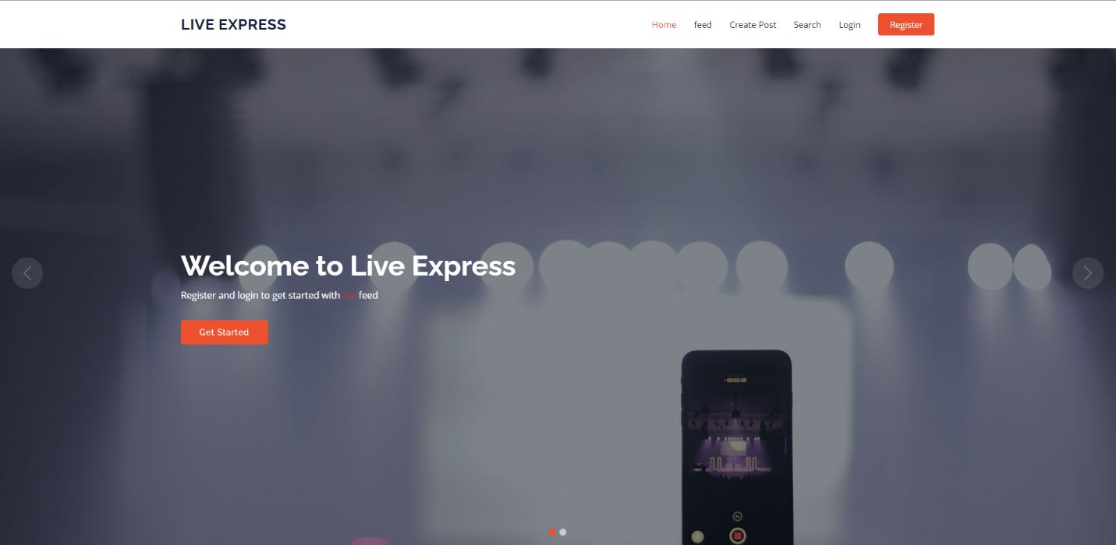

*Figure 34. Home Site*

### Feed

The Feed page is where all user posts end up. By scrolling up or down on this page you can view all posts created by users who have used LivExpress.

Site:

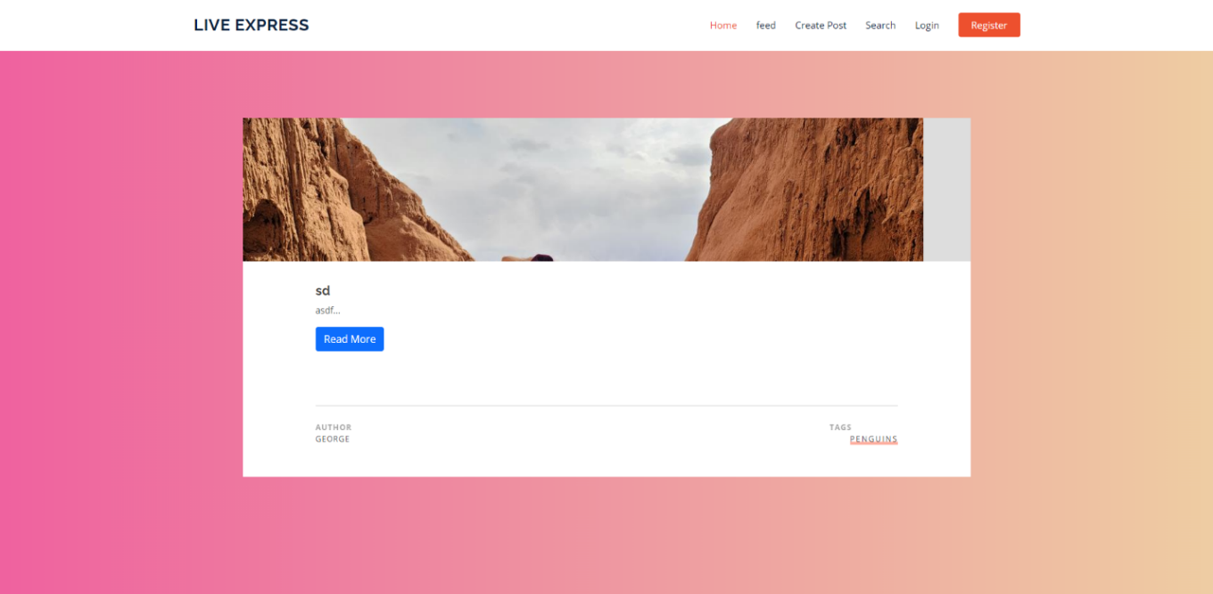

*Figure 35. Feed Site*

### Post

The Post page is the page you are taken to when you select the “Read More” option on any post in the Feed page that was just covered. This page contains the full picture associated with the post as well as the title, and text content that the user submitted with the picture.

Site:

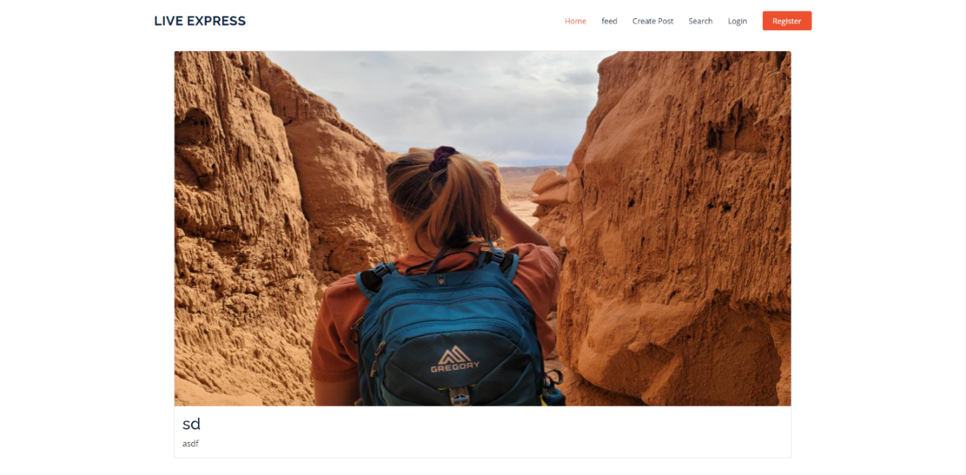

*Figure 36. Post Site*

### Create Post

The Create Post page is where users will be able to create the posts that were seen in the Feed and Post pages. Here, users will enter a hash-tag to associate their picture with, create a title, and add text to give the picture context.

Site:

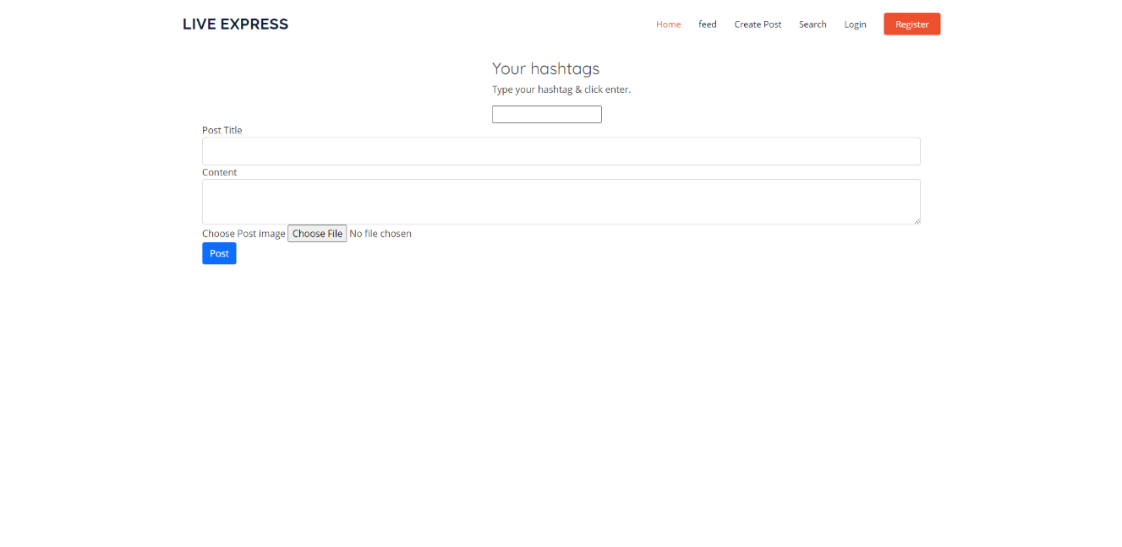

*Figure 37. Create Post Site*

### Search

The Search page is where users will be able to filter down posts by what they want to see. The page contains fields where the user will be able to filter down by post title or hash-tag.

Site:

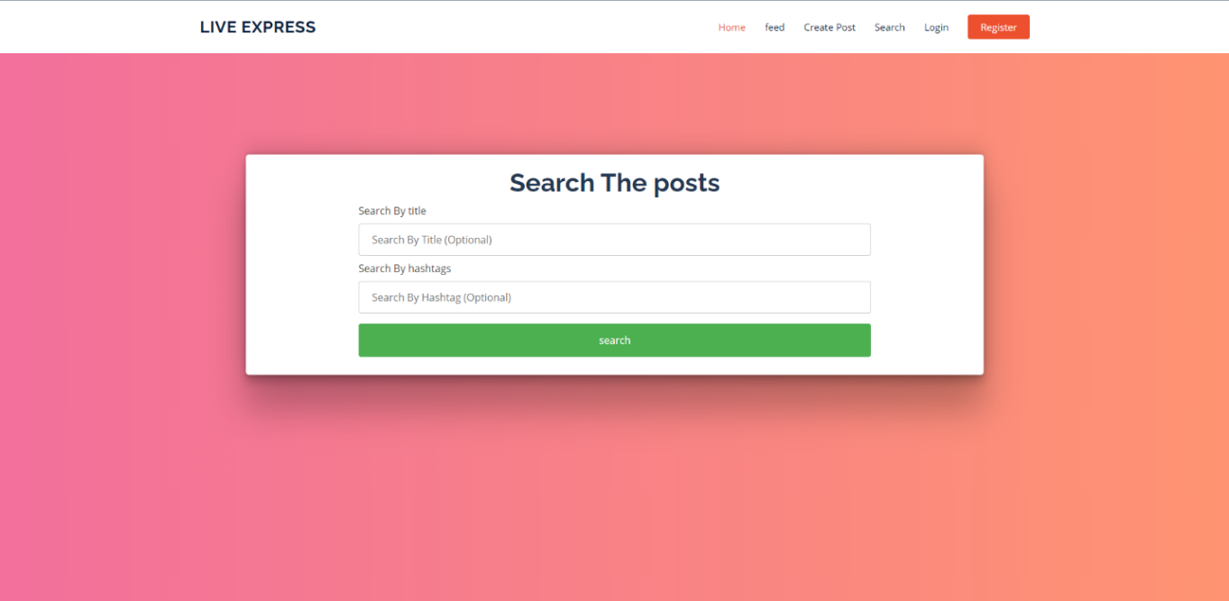

*Figure 38. Search Site*

### Login

If a user already has a registered account, the Login page is where they will be able to enter their credentials to gain access to their account. Entering their username and password will grant them access to their account, which in turn grants them additional privileges that a guest user will not be able to utilize. If correctly entered, the user will be logged in. If done incorrectly, the page will display a red error message banner across the top of the screen.

Site:

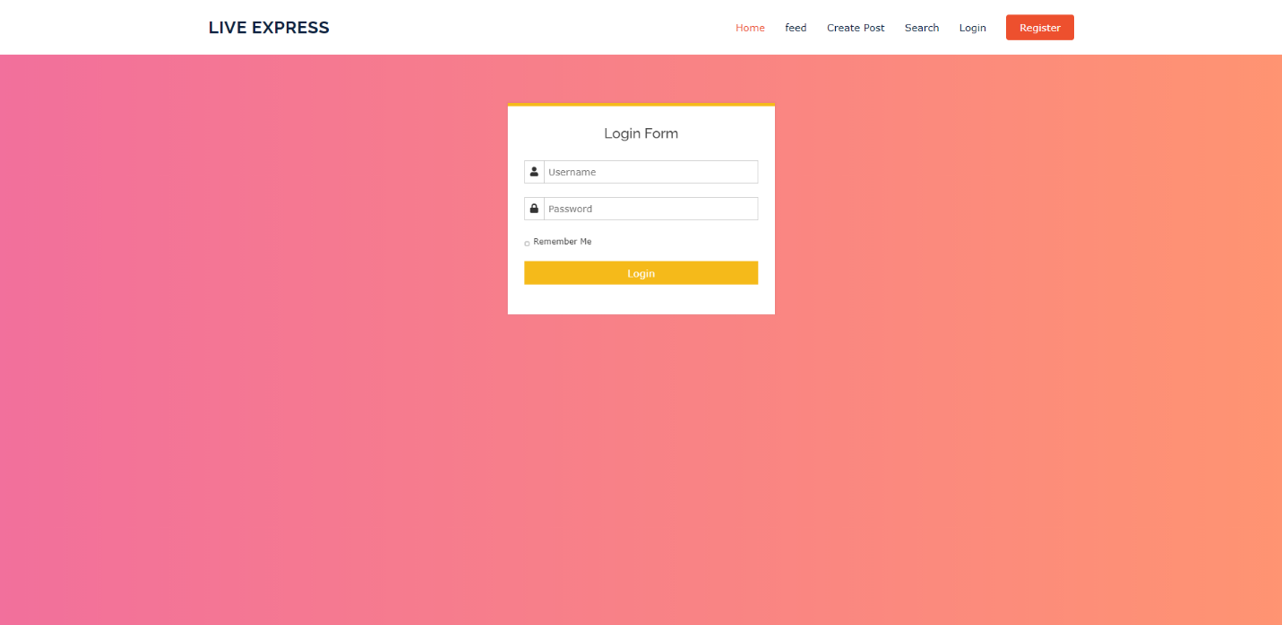

*Figure 39. Login Site*

### Register

The Registration page is where a user will enter in a series of credentials to create a user account. The credentials include a phone number, first and last name, email, password, a confirmation of that password, and a Gender selection, followed by selecting the “Register” option. If done correctly, this will register the account and take the user to the login screen. If done incorrectly, the page will display a red error message banner across the top of the screen.

Site:

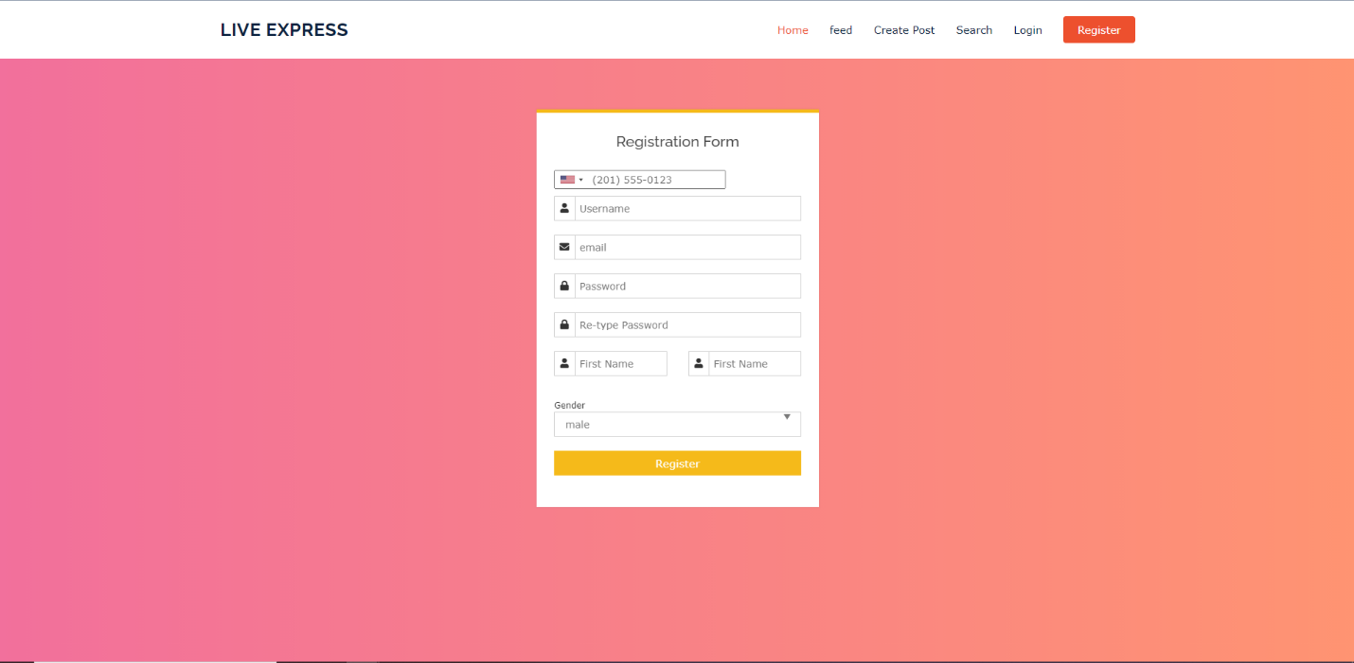

*Figure 40. Register Site*

## Phase II

In phase II, we discussed the back-end portion of the website (using Python, CSS, and SQL database), which forces the components, and together, facilitates in the front-end (user-facing) portion of the website.

### Installing SQLAlchemy

To install SQLAlchemy, the command below is used in the terminal or the command prompt.

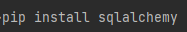

*Figure 41.* Install SQLAlchemy

The SQLAlchemy installation is verified to ascertain whether it was successful or not using the following command in the command prompt or in the terminal...

sqlalchemy. _version_

SQLAlchemy is then imported.

### Installing Database

By default, SQLAlchemy usually works with SQLite database without installation of any extra drivers. Users are required to install a DBAPI complaint driver, which must be specific to the database under use, to utilize MySQL database. This project used SQLite.

### Feed

User posts are stored in the database to enable access by other viewers and owners in future. After successful creation and configuration of the database, a python script is written that will read the information in the database and display it on the interface for viewing by the users.

### Delete or Update Post

Users may delete posts that they created or updated by them. A python code to delete or update the posts from the database is written.

### Create Post

User posts are sent to the database upon clicking the submit button. The posts should be posted in their original state without distortion. The posts from numerous should be systematically organized in the database for easy reading and retrieval.

### Search

The search is a text box that allows users to type and enter a hashtag or title of their post. The post will be displayed if it is saved in the database. In the backend, the python code filters the posts based on the hashtag or the title requested by the user.

### Login

If a user is already registered in the live express application, and the credentials are in the database, the user is prompted to input the username and password for verification purpose to gain access into the platform. A python code is written to always confirm whether the credentials entered are like those saved in the database.

#### Login Error

If the credentials are correct, the user is granted the permission to access the app and is taken to another page. Nonetheless, if the credentials are not correct, a text will appear informing the user that the login is unsuccessful and should re-check the username and password.

### Register

Users willing or interested to use the application are required to create an account. Several textboxes are displayed, and the user is required to fill each text box with the right information. The user then clicks the register button, which send the information to the database for storage. A python code sends the data to the SQLAlchemy database.

### Handling Errors

* Error 404
  + The error 404 will appear on the screen when the user is using the app. It will appear when the user types a wrong uniform resource locator on a browser while searching for the application. Moreover, it can appear when the application is being updated since it is temporarily disabled or removed. Error 403
* Error 403
  + Appears when the user tries to access a resource without permission or authority. It is a forbidden client error.
* Error 500
  + The statement “Error 500” appears when the server encounters unexpected conditions or error while executing the user’s request. Therefore, it is a system-based error (The Python Code is shown below, Figure 55).
* Error 504
  + The statement “Error 504” appears when an attempt has been made to submit a text file rather than an image file, which are the only files approved to be uploaded into the feed.

### Contact Us

The admin manages the contact page support tickets that are submitted to an email to respond to any user’s inquiry. The user must fill out a ticket form that uses flask-email to submit the form to an email. This page uses python scripts, along with the flask-mail package version 0.9.0, allowing the form to submit to the support team email account. The LivExpress support email uses Gmail sever smtp.gmail.com through port 465.

### Requirements

The back-end team installs and uses different Python packages to successfully run this project. The packages are listed in the Requirement.txt document within the program. If all the required packages (shown in *figure 42),* and their respected versions are not properly installed, then the program will not run.

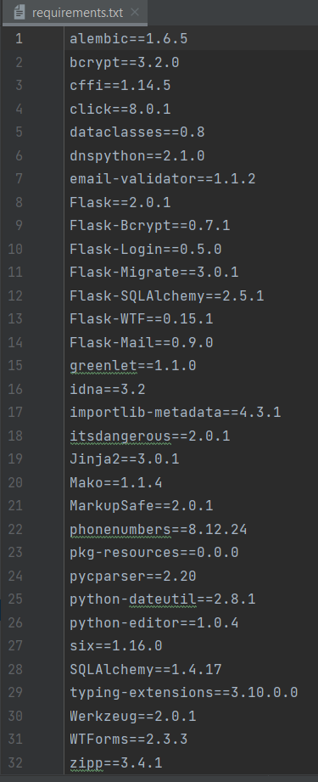

*Figure 42.* Required Python Packages

## Phase III

Phase III report focuses on testing all the components to ensure that all security functions are properly enforced, and that user’s data is safe and secure and working as intended. Areas that are the most susceptible to a breach are the *login* and *Create Post* pages. Attempts to breach those vulnerable areas were conducted to further confirm that security is fully in place. There have also been a few changes made to the LivExpress site.

### Passwords

Users’ passwords are stored using hashing. Hashing allows the plain text password to be stored in another string format, called hashed passwords. Thus, allowing to protect the user’s password from getting used by a user with malicious intent.

### SQL Database

All data is stored securely within the SQL database. The database is password protected so that users other than the admin team are not able to access the data within the database. The database is secure with a strong password and users’ data are stored within tables. The password is stored inside the database with the hashed password instead of plain text, along with other data pertaining to the users’ account, such as, username, phone number, email address, etc.

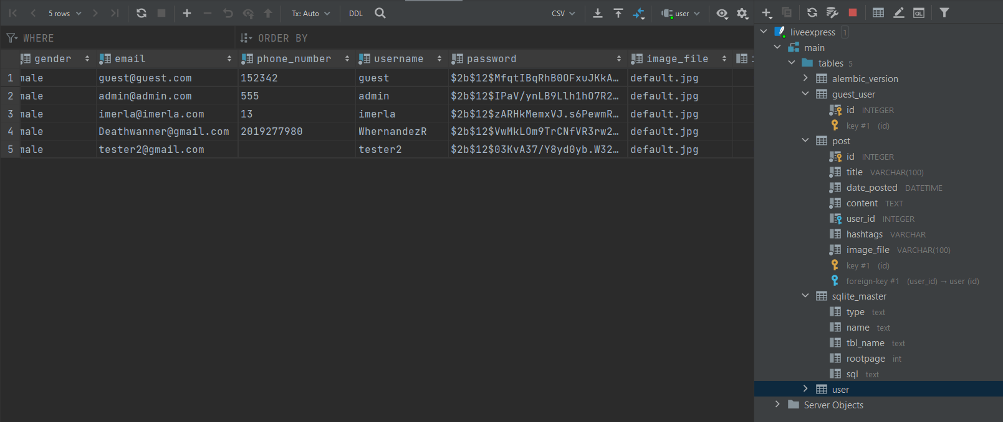

*Figure 43. User Data SQL Database*

### Breaches

An attempt to breach a user’s account by injecting the category parameters into the URL was found to be secure. A test was done by inserting the username and password into the login pages URL using the following syntax below. However, this was found to not work, which shows that a user cannot breach a user’s account by attempting to inject certain parameters within the URL.

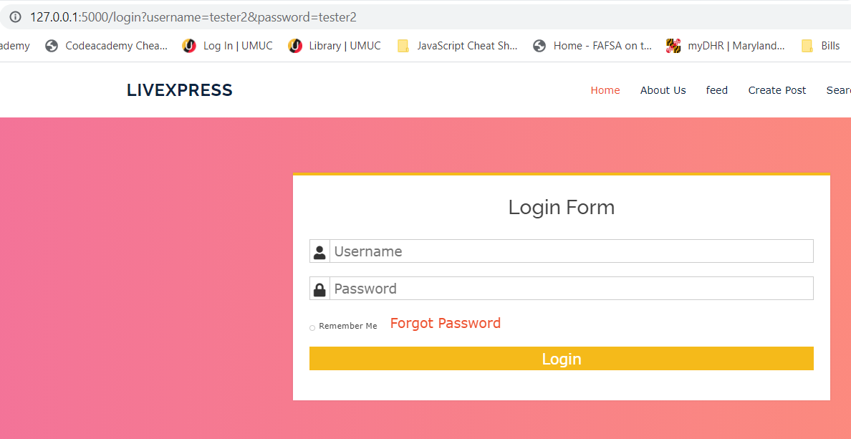

*Figure 44.* Injection Attempt to Bypass Login Screen

For users to not inject malicious content when uploading images to the feed, users are restricted from posting word or pdf files. Only files that are allowed to be uploaded are image files. When trying to upload a file other than an image, the user will see a 504-error code (*see Figure 45),* stating only image files are supported.

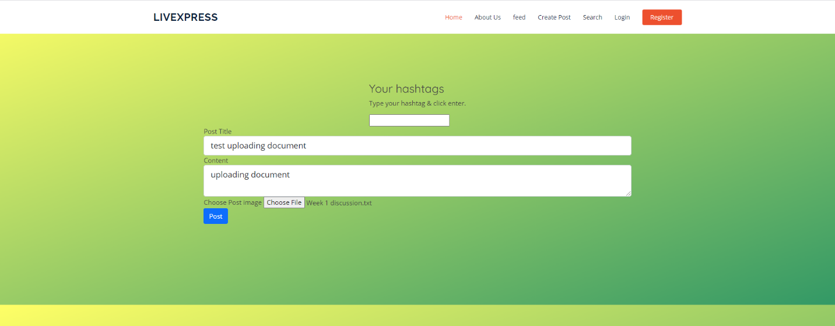

*Figure 45.* Attempt to Upload Text File

### Contact Form - Email Support Functionality

When the user enters data into the form there is a support ticket that is generated that is sent to [livexpress.help@gmail.com](mailto:livexpress.help@gmail.com) account. The form tickets go to all the developers who have access to the Gmail account. You can see a snippet of the Gmail account in the following Figure 62, below.

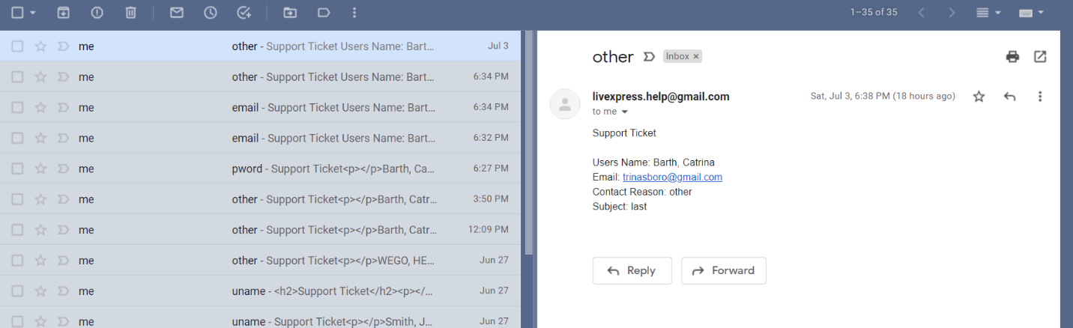

*Figure 46.* LivExpress Support Tickets Submitted to [livexpress.help@gmail.com](mailto:livexpress.help@gmail.com) Account.

# CONCLUSION

We plan to concentrate on building a mobile app because all of our team members agreed on making this web service more appealing. It will no longer be limited to desktop or laptop computers in the near future. Making a mobile app for LivExpress would improve usability while also providing entertainment for the user.

Over the past few weeks, LivExpress went from an idea to a reality, to something more. This project has been an absolute pleasure to work on solely due to the team and heart that went into it. If there is one thing we learned from this more than anything else, it is the value of teamwork when utilized effectively. As is always the case, this project did not end up the way we thought it would. As the timeline moves along, you have new ideas, and thoughts. These are good to have and they make the end product so much better if you take advantage of them rather than wallow in what could have been. This, as we came to realize, is so much more apparent when you have 5 minds all dedicated to 1 project. All that being said though, we worked with the ideas of others wonderfully, and through coordination, were able to make the best product that we possibly could in an 8 week period. Given the chance to re-do this course it would be fantastic to know in advance where the project would end up so that we could start from there and make changes to that in order to make an even better final product. Hindsight is 20/20 though, and short of seeing into the future, we all can proudly present what we came up with.

This was a labor of love for us, and we all hope it shows.

* LivExpress Team

# RESOURCES

*Denman, J. (2020, August 7). Agile FAQ: Get started with these Agile basics.* SearchSoftwareQuality. https://searchsoftwarequality.techtarget.com/feature/Agile-basics-FAQ-Getting-started-with-Agile.

Oracle. (1997). Privileges and Roles. Oracle7 Server Concepts Manual. <https://docs.oracle.com/cd/A57673_01/DOC/server/doc/SCN73/ch18.htm>.

*Paletton, the color scheme designer*. Paletton. (n.d.). https://paletton.com/#uid=1000u0kllllaFw0g0qFqFg0w0aF.

*Udemy Online Courses* – Learn Anything, On Your Schedule. Udemy (n.a.). https://www.udemy.com/.

*W3Schools*. W3Schools Online Web Tutorials. (n.d.). https://www.w3schools.com/.

*Where Developers Learn, Share, & Build Careers*. Stack Overflow. (n.d.). https://stackoverflow.com/.